**Object Oriented Programming**

**WWS 37 - PROJECT INSPECTION**

**DATE: 24th february 2022**

Inspector Team

1 3

2 6

3 9

4 5

5 1

6 8

7 2

8 4

9 7

Modularity /10 packages 7:47-7:52

Clean code /10 variables, vertical/horizontal, CamelCase, nouns, verbs, comments 7:57-8:07

MVC /10 View (no code, calling to functions), Controller/Utils (functions), Model (no BR methods, only attributes POJO) 8:10 - 8:20

One design pattern /10 Singleton, Template Method, Strategy 8:22 - 8:27

Diagrams consistency /10 Use Case -> actions (GUI), Class Diagram -> View, Model 8:27 - 8:37

Unit tests /10 assert(expected,actual) -> 100, run (error (red), green 8:37 - 8:42

GUI navigability /10 navigate to the system options 8:47-8:52

GUI fields validation /10 every TextField must be validated (-1) 8:52:-9:02

Functionality /10 3 to 4 computations, MongoDB Atlas 9:02-9:07

MongoDB /10 Data in the Cloud 9:07-9:12

______________________________

TOTAL /100

Modularity

Clean code

MVC

One design pattern

Diagrams consistency

Unit tests

GUI navigability

GUI fields validation

Functionality

MongoDB

________________________________________________________________________

Inspector: T5 (JavaLegendsTeam) Leader: Guitarra Jhon

Team: T1 (Alpha Team) Leader: Altamirano Cristhian

Project: Smart Home

1 ALMACHE LITARDO ANDERSON MOISES

2 ALTAMIRANO BENALCAZAR CRISTHIAN ALEXANDER

3 ALVAREZ RAMIREZ MICHELLE ESTEFANIA

4 ANDRADE CARATE ALAN DAMIAN

5 ANDRANGO ESPINOSA ALEX PAÚL

Modularity 10/10

Clean code 9/10

MVC 8/10

One design pattern 0/10

Diagrams consistency 8/10

Unit tests 10/10

GUI navigability 10/10

GUI fields validation 10/10

Functionality 10/10

MongoDB 10/10

______________________________

TOTAL 85/100

Modularity

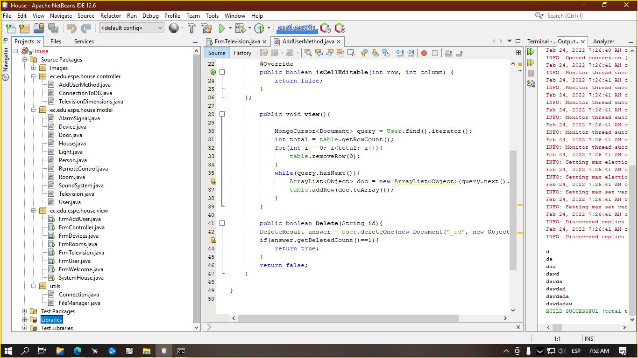

Clean code

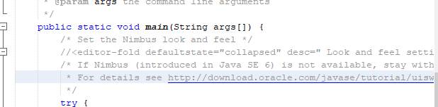

inspector: unremoved comments in code.

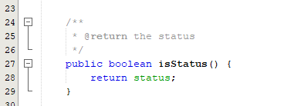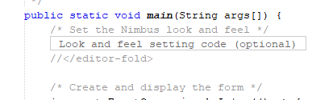

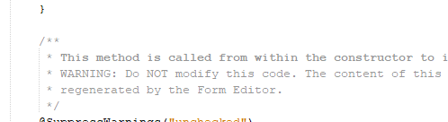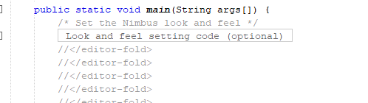

inspector: repeat mistake

MVC

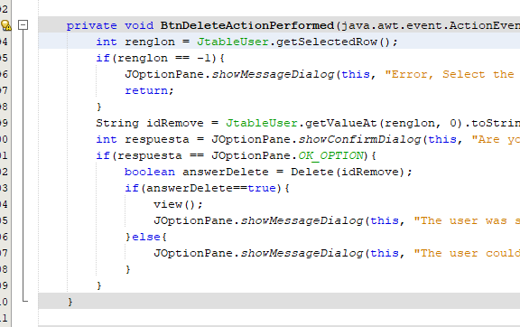

inspector: code in the button.

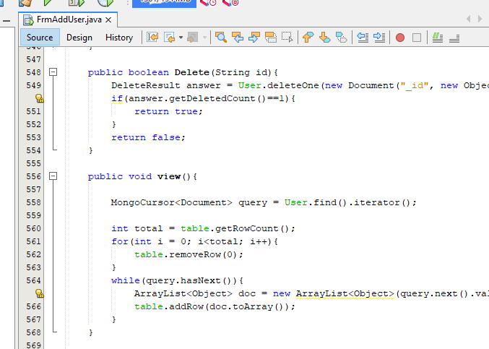}

inspector: Code in Frm(view)

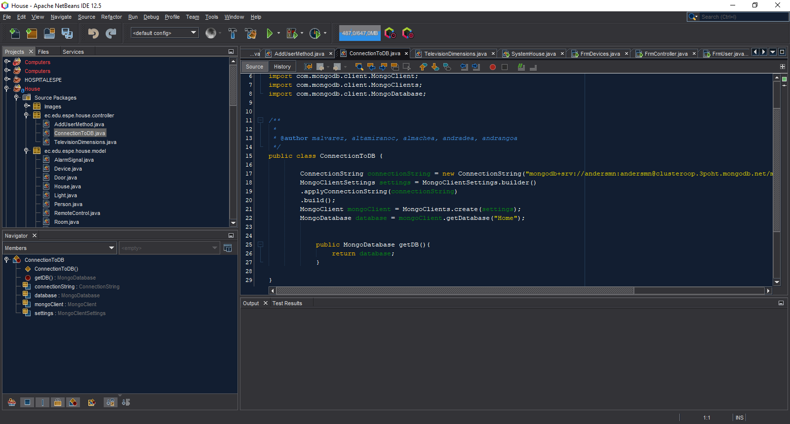

Connection is in the (Controller)

One design pattern

Diagrams consistency

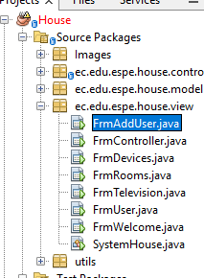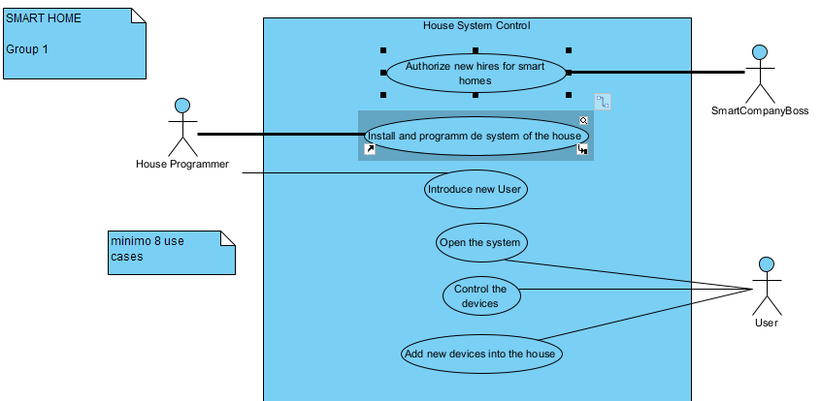

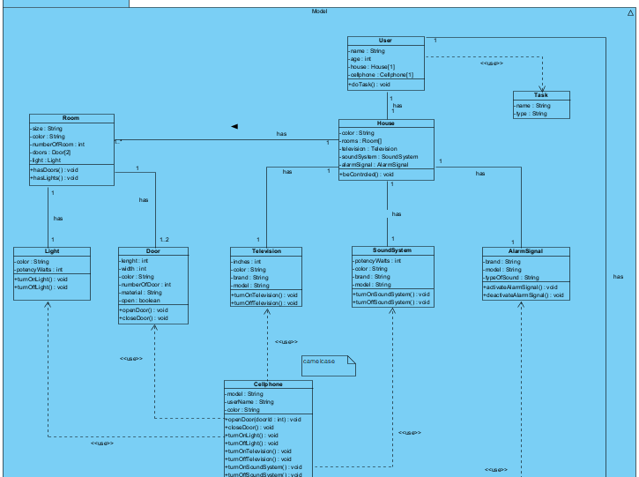

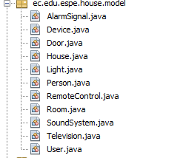

Unit tests

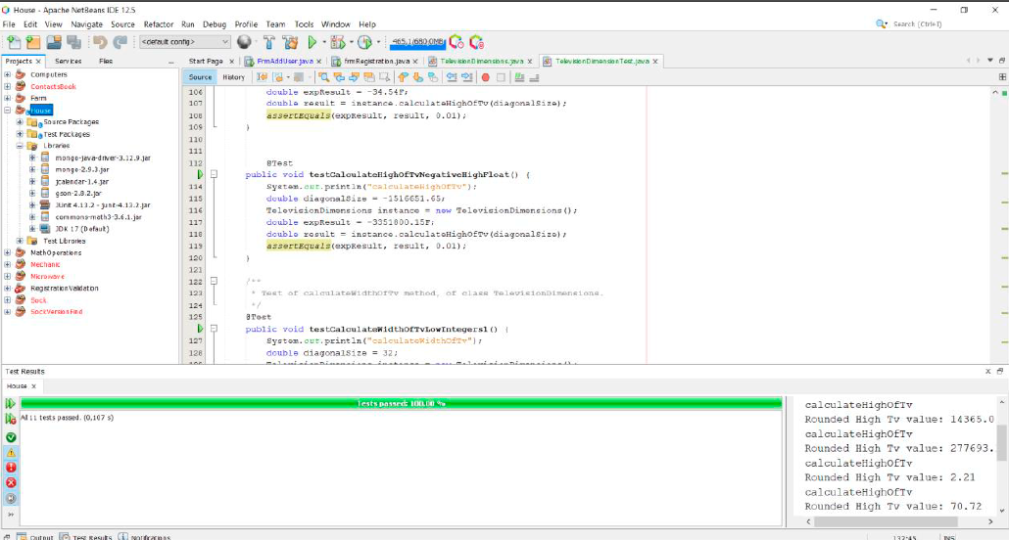

inspector: allp ok

GUI navigability

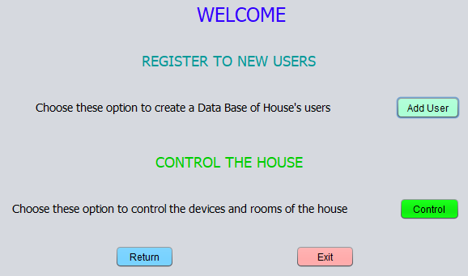

inspector:all OK

GUI fields validation

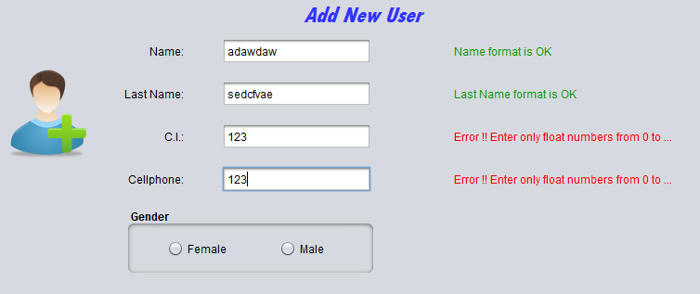

inspector: all OK

Functionality

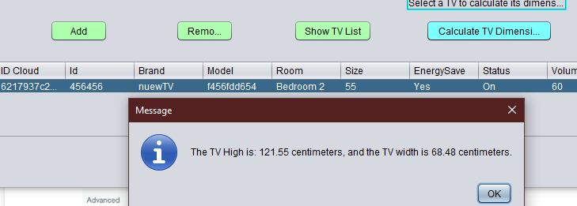

all ok

MongoDB

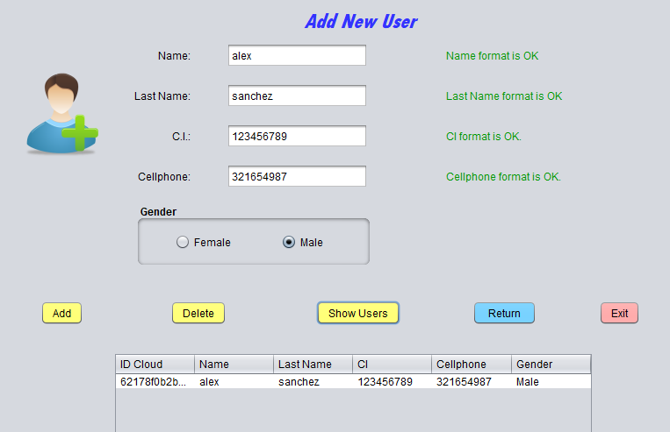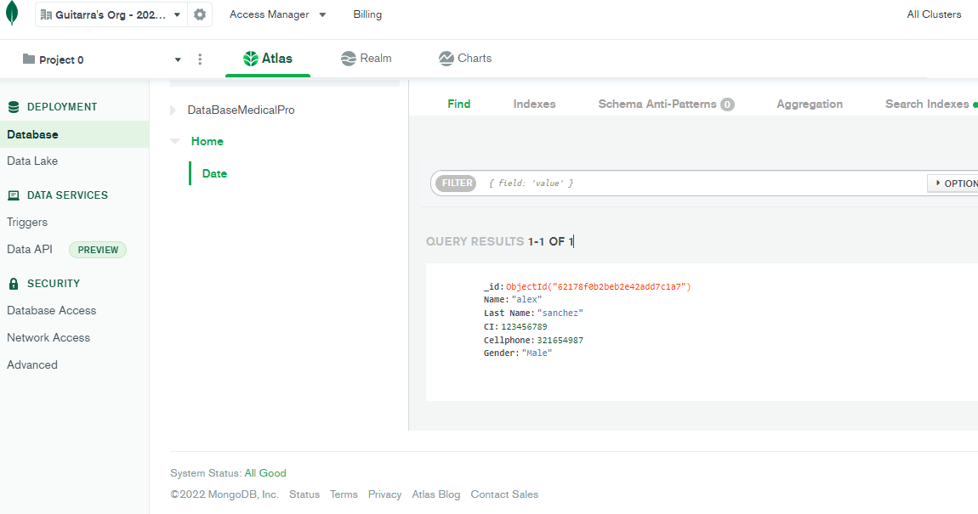

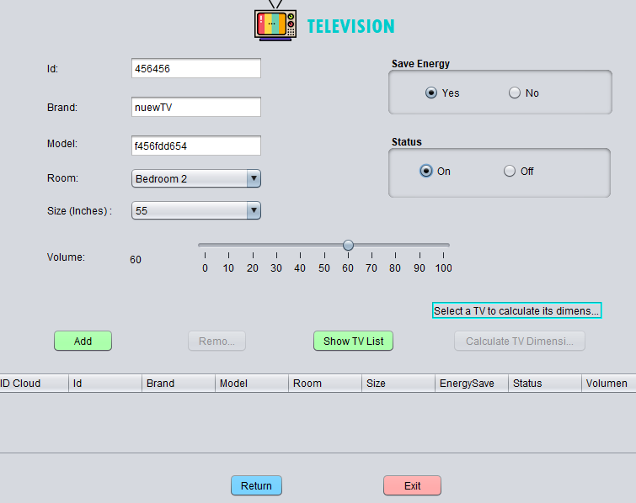

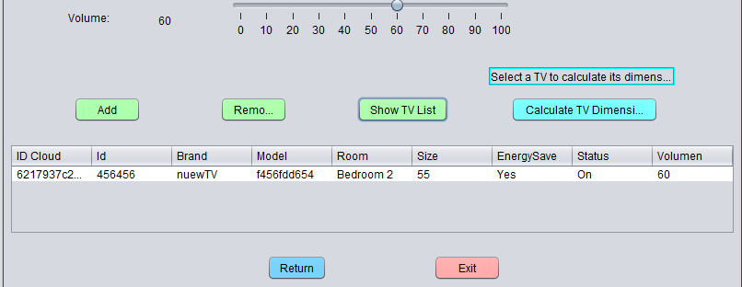

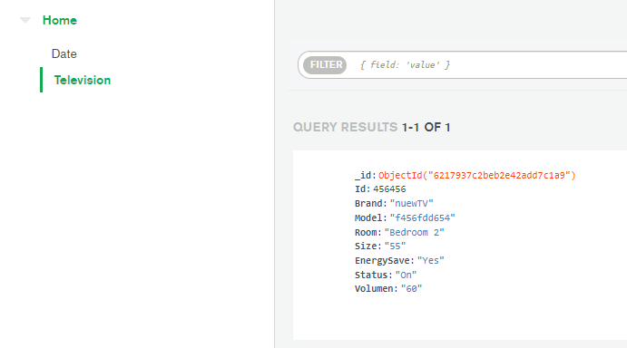

inspector: all OK

________________________________________________________________________

link: <https://youtu.be/D40lz0mZE78>

Inspector: T7 (Project X) Leader: Ruano Alexander

Team: T2 (BigBoysTeam) Leader:Pablo Bustillos

Project: Inventory of medical supplies

6 ARROBA SOLORZANO CRISTIAN ALEXANDER

7 ASUMAZA GUALOTO DYLAN ALEXANDER

8 BRAVO RODRIGUEZ KATHERIN DAYANNE

9 BRAVO VILLALOBOS CHRISTIAN DAVID

10 BUSTILLOS MONTENEGRO PABLO SEBASTIAN

Modularity 10/10 Modularity is fine

Clean code 8.5/10 You cannot declare variables on the same line,You shouldn't see comments

MVC 8/10

One design pattern 0/10

Diagrams consistency 8/10 does not match the classes with the diagram, there are no use cases

Unit tests 8/10

GUI navigability 10/10 If you have a good navigation

GUI fields validation 10/10

Functionality 10/10

MongoDB 10/10

______________________________

TOTAL 82.5/100

Modularity

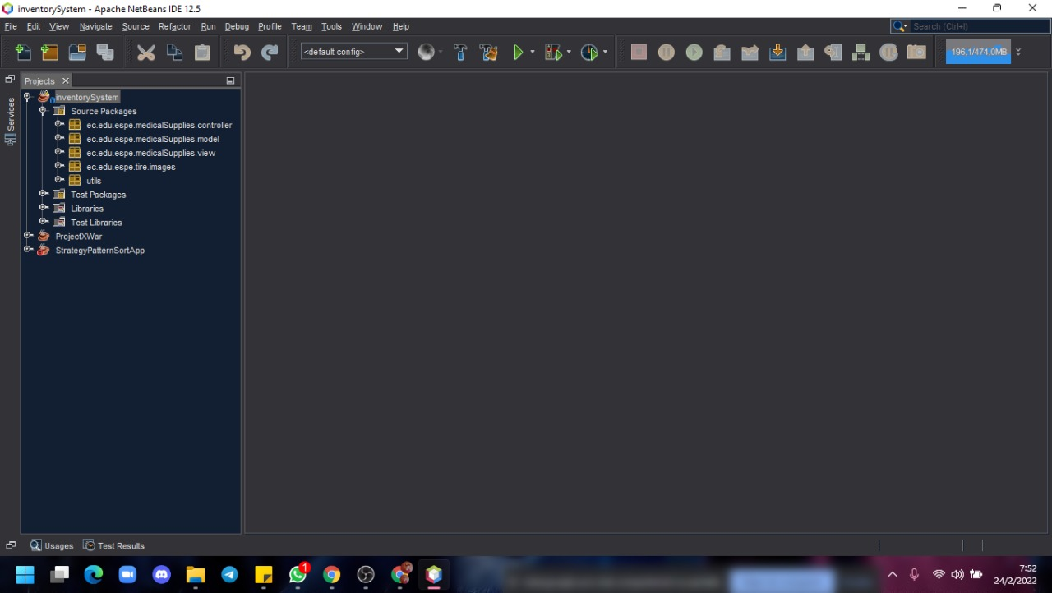

Clean code

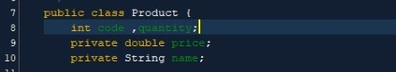

You shouldn't see comments

MVC

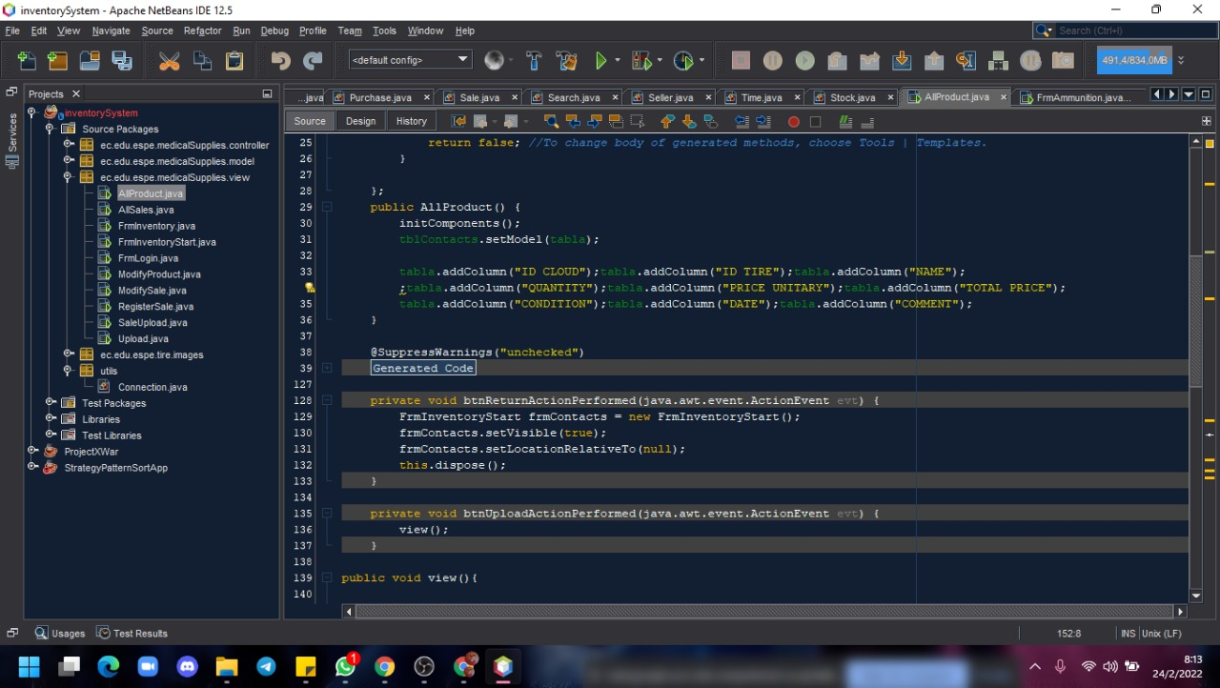

One design pattern

Diagrams consistency

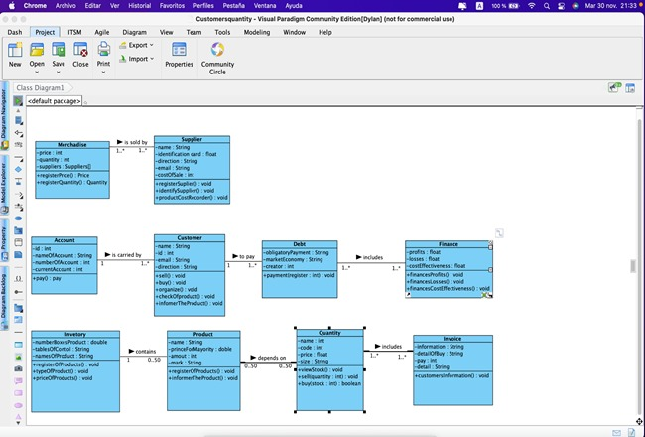

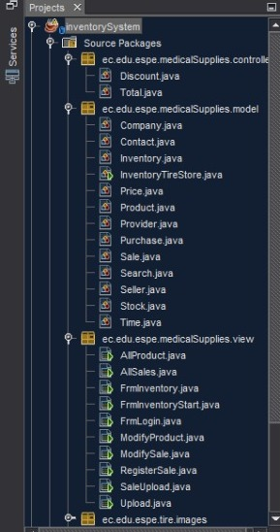

Unit tests

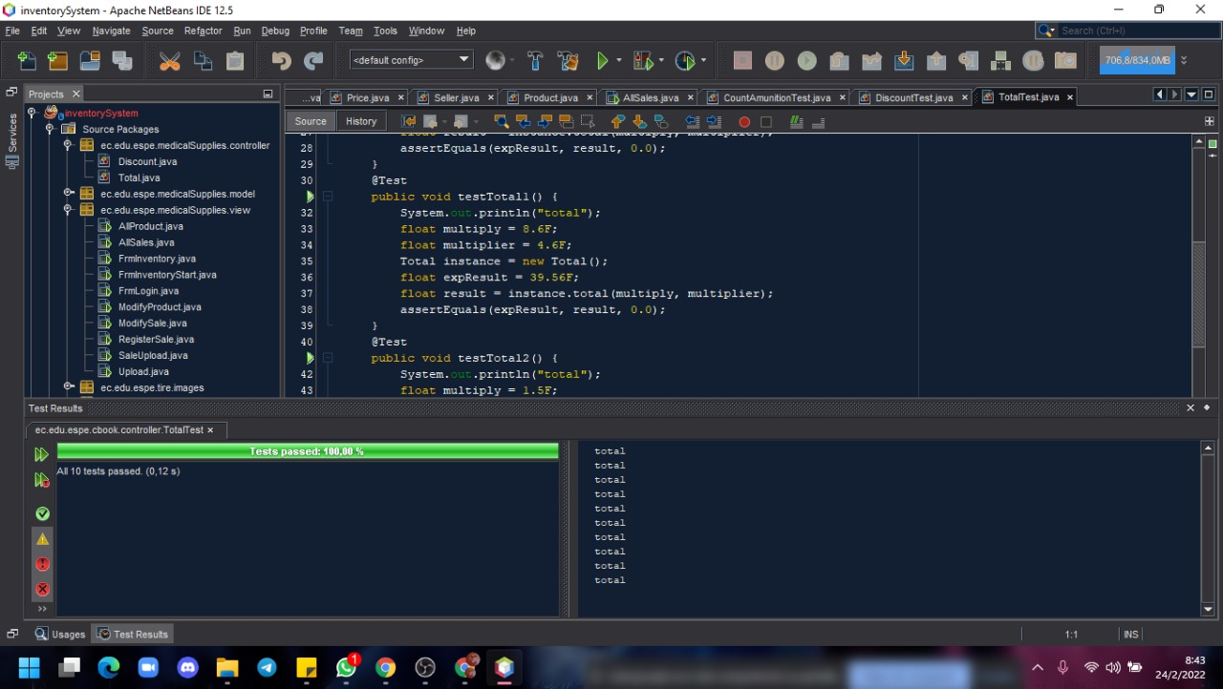

GUI navigability

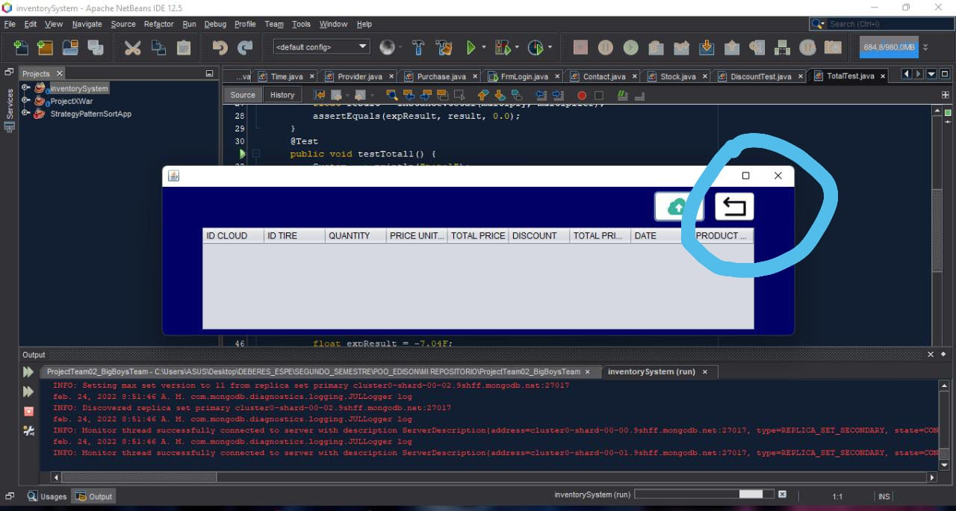

If it is worth the screens and if it is possible to return to the other screens

GUI fields validation

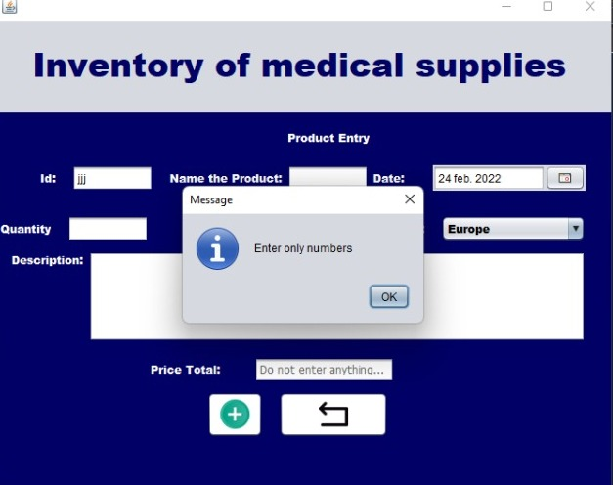

Functionality

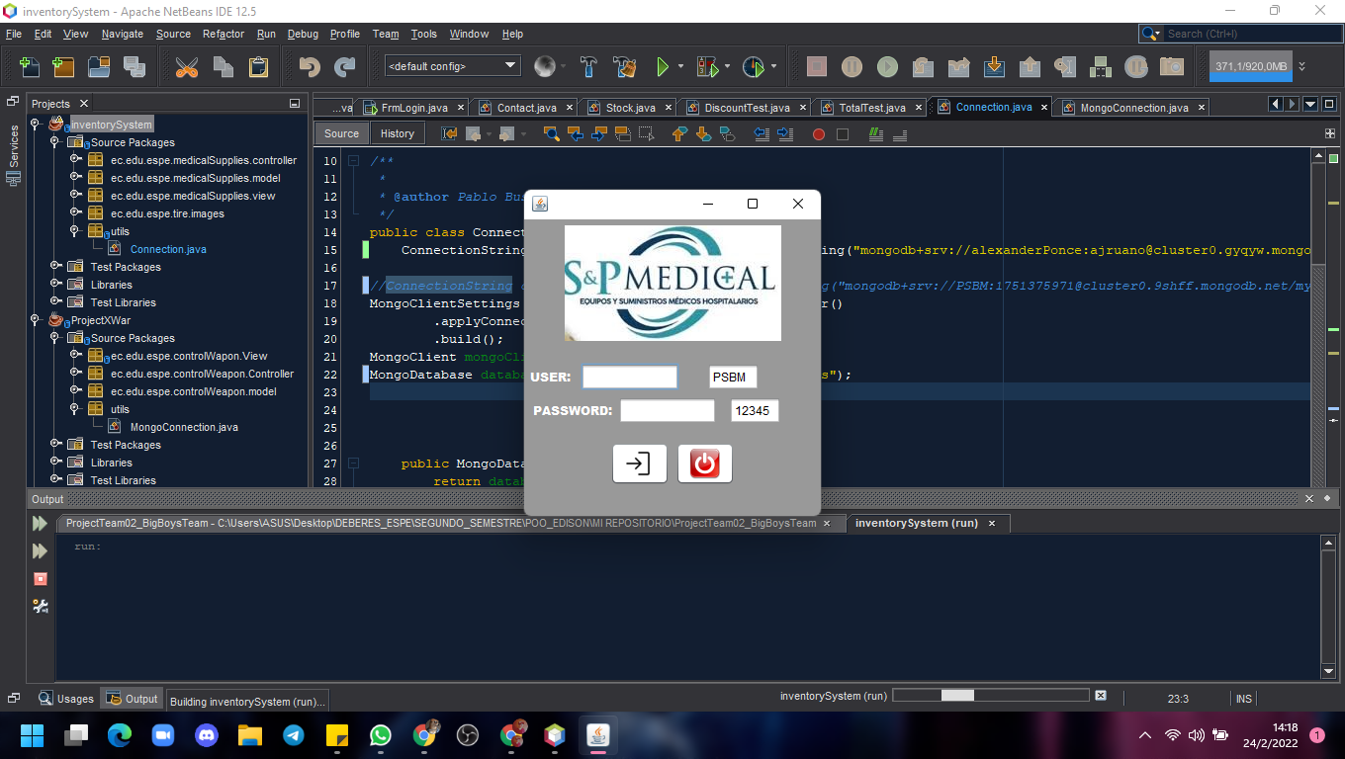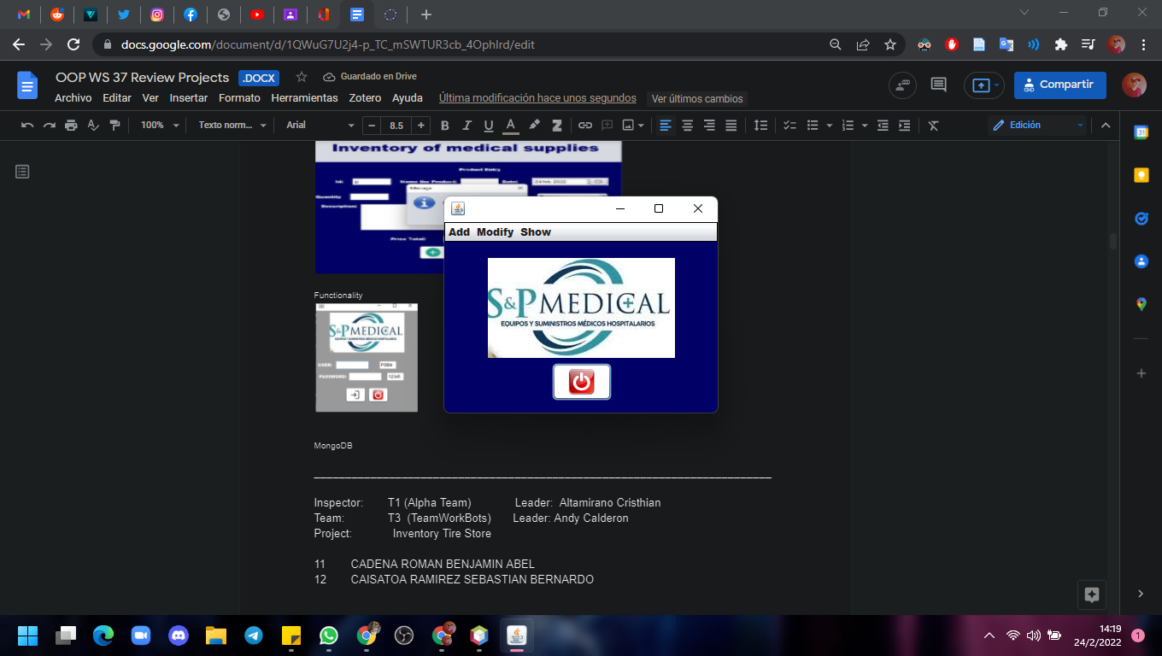

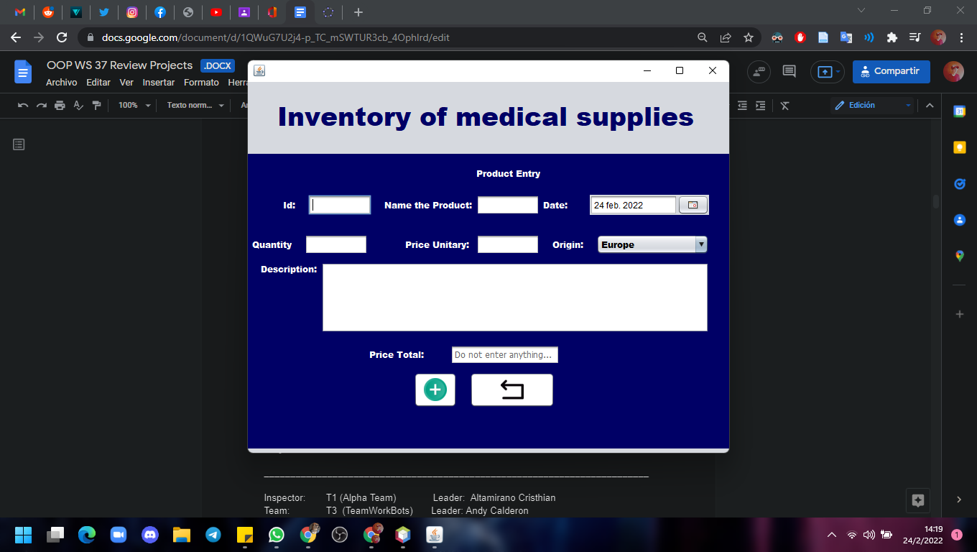

MongoDB

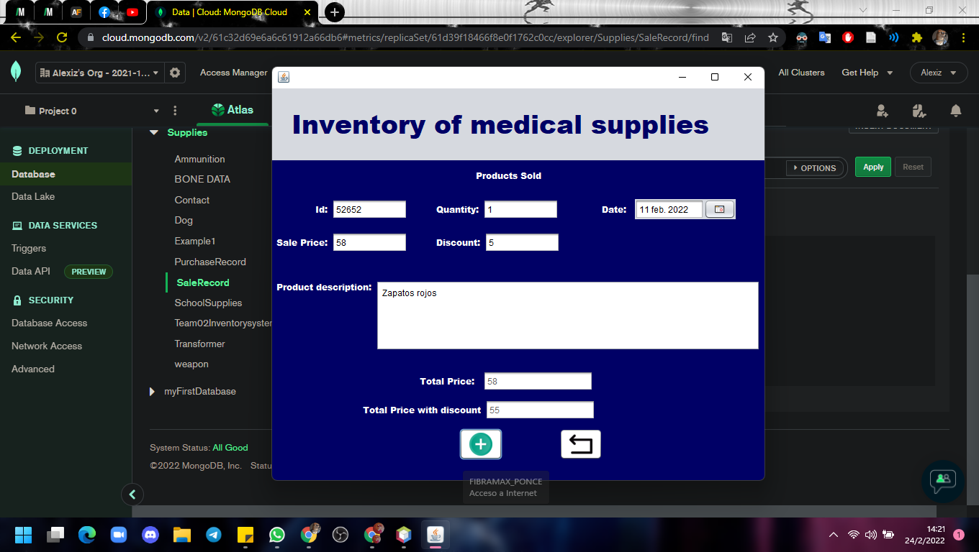

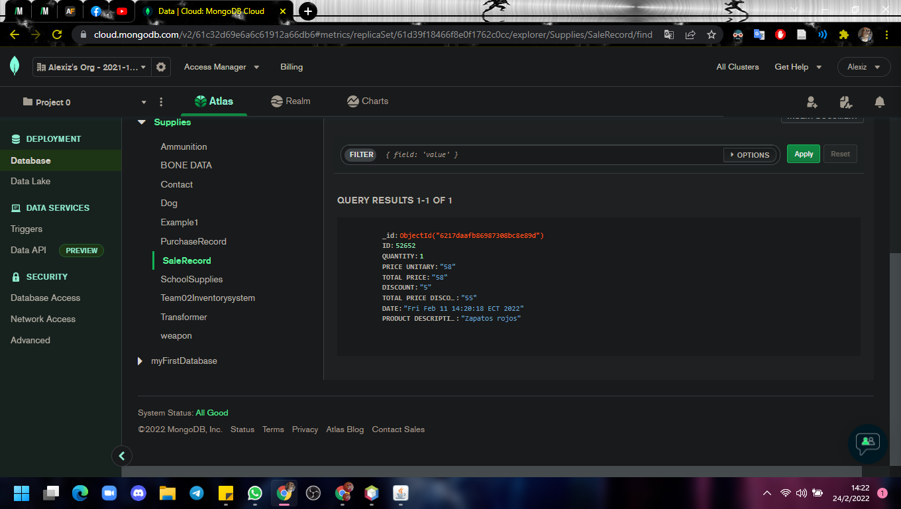

_________________________________________________________________________

Inspector: T1 (Alpha Team) Leader: Altamirano Cristhian

Team: T3 (TeamWorkBots) Leader: Andy Calderon

Project: Inventory Tire Store

11 CADENA ROMAN BENJAMIN ABEL

12 CAISATOA RAMIREZ SEBASTIAN BERNARDO

13 CALDERON MERCHAN ANDY JOSUE

14 CORREA RUIZ KERLY YADIRA

15 CRUZ PANTOJA DARLING MICAELA

Modularity 10/10

Clean code 8/10

MVC 9/10

One design pattern 0/10

Diagrams consistency 9/10

Unit tests 9/10

GUI navigability 10/10

GUI fields validation 10/10

Functionality 10/10

MongoDB 10/10

______________________________

**TOTAL 85 /100**

**Modularity:**

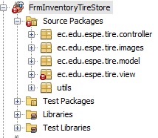 The packages are correctly distributed. THAT IS CORRECT

**Clean code:**

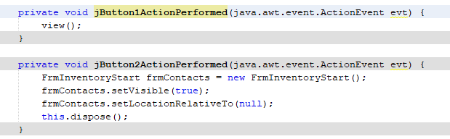 Generic names of buttons. The jButton1 must have been changed of name.

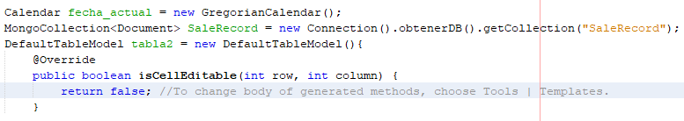

The program has commented lines, those must be deleted.

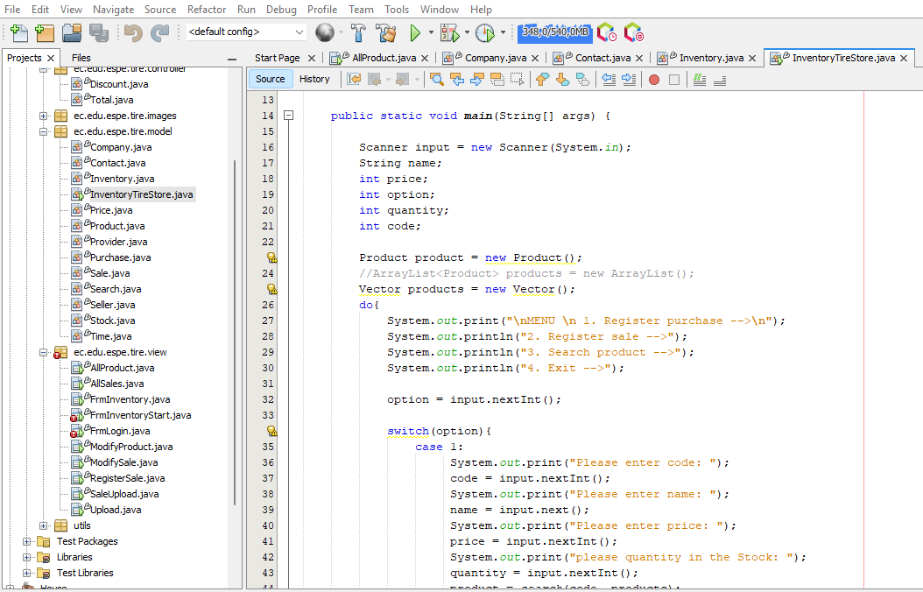

The class called Inventory Tire Store, must have just atributes, but no methods, because it belongs to the Model Package.

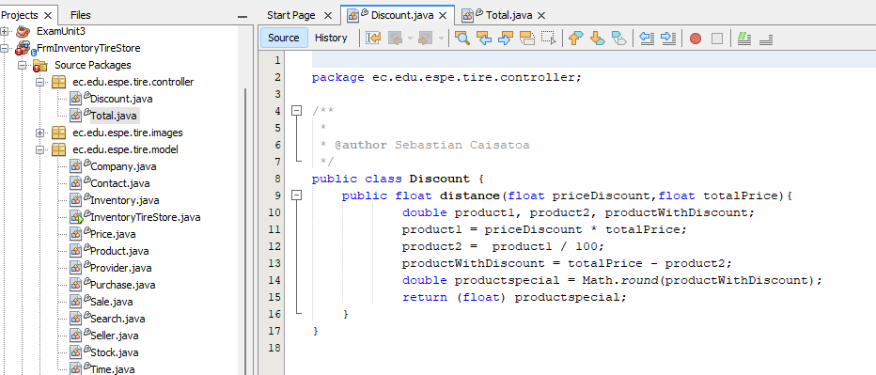

The class called Discount, has just methods, because it belongs to the Controller Package. THAT I.S CORRECT

**One design pattern:**

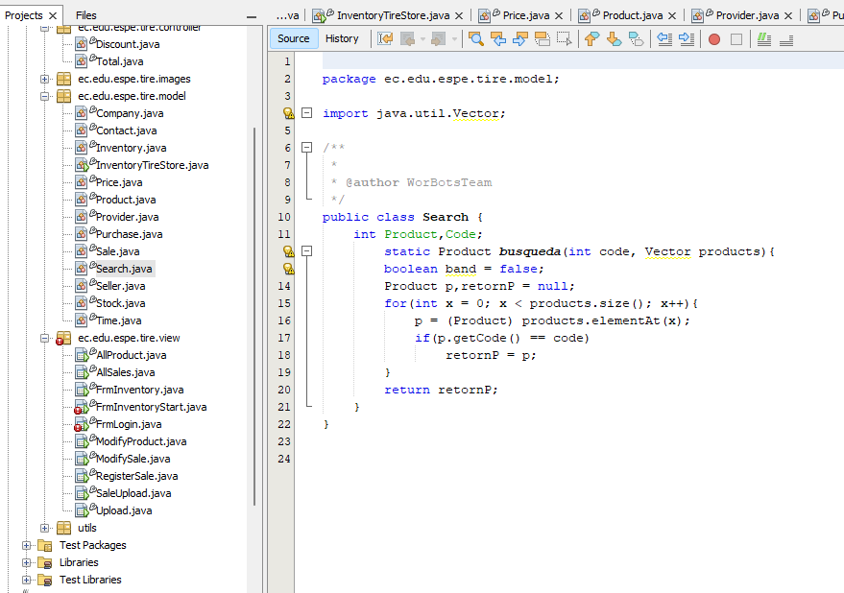

**Diagrams consistency**

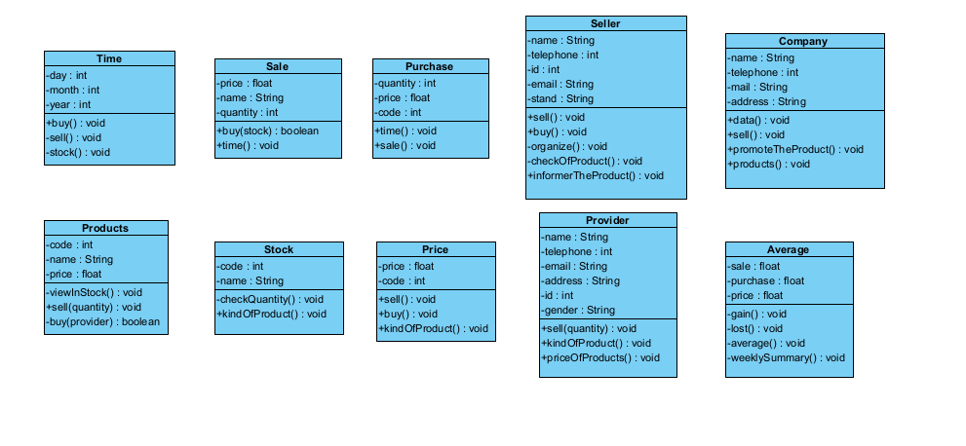

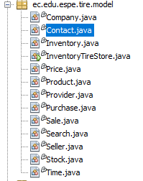

**Unit tests**

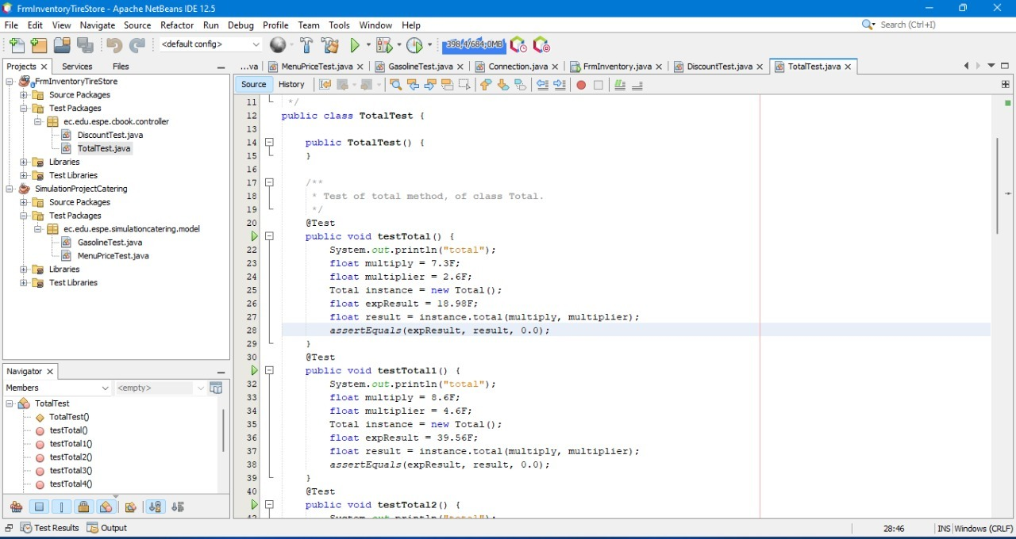

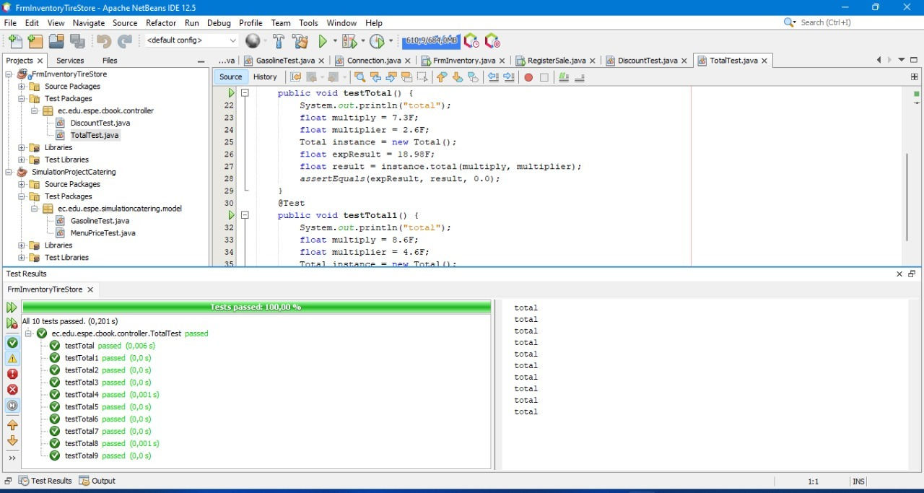

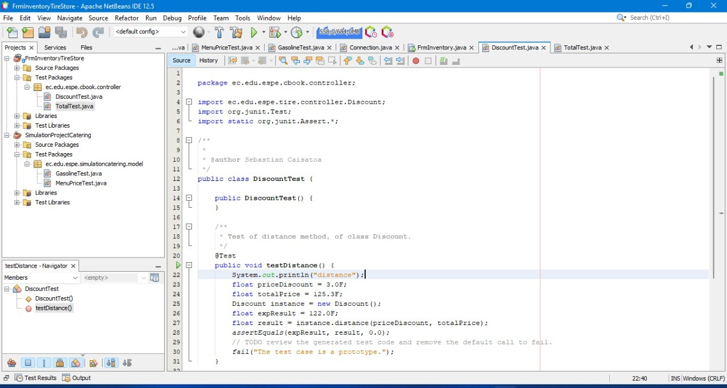

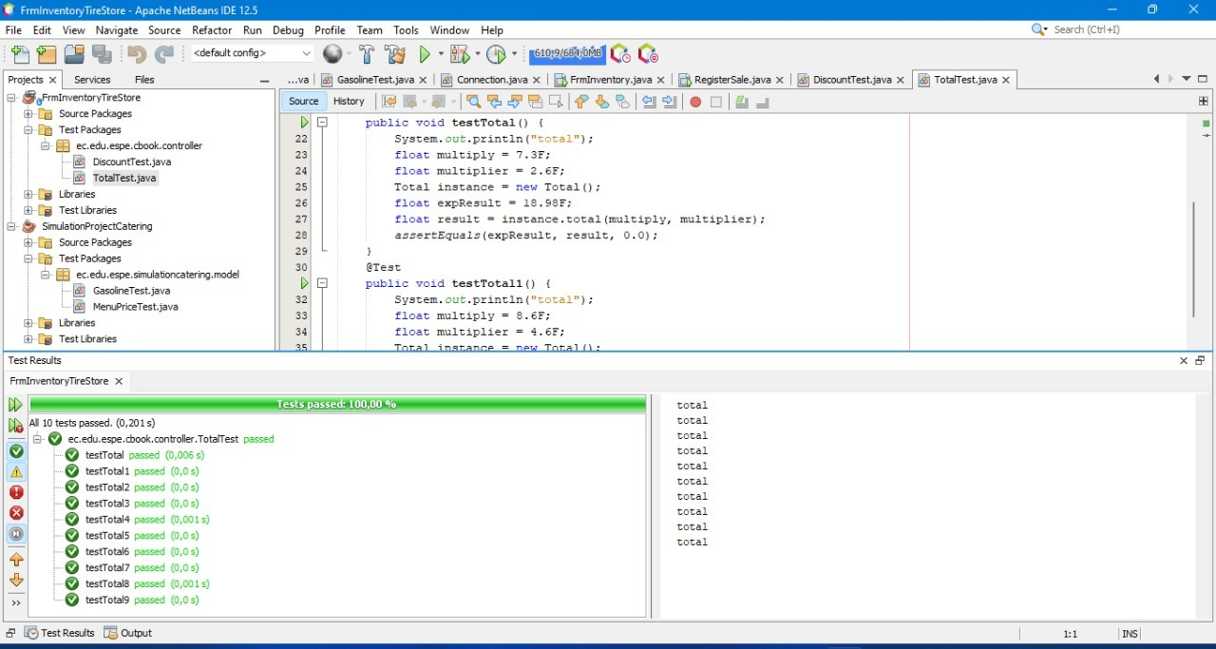

**GUI navigability:**

The video shows the navegability S/N

<https://youtu.be/lMolYcEhrMM>

**GUI fields validation:** OK

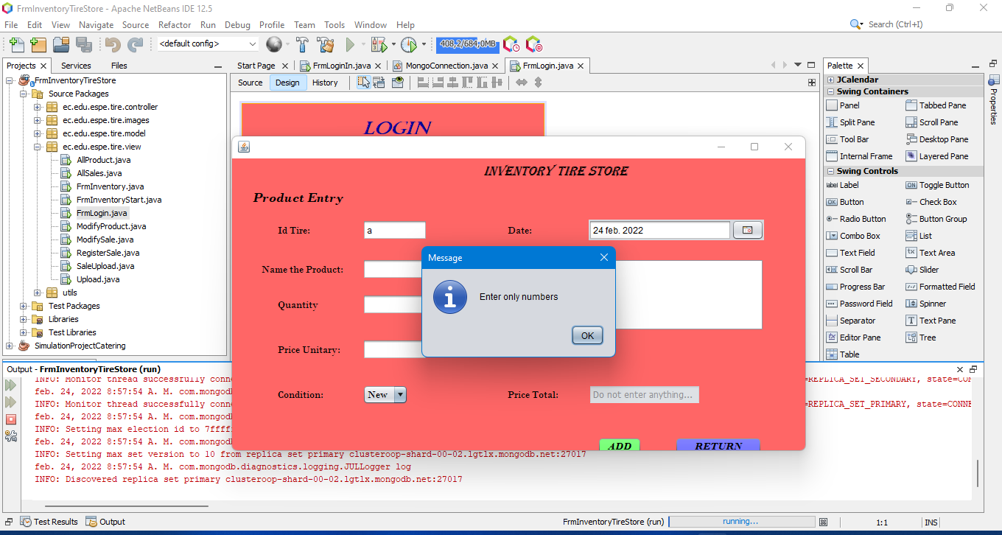

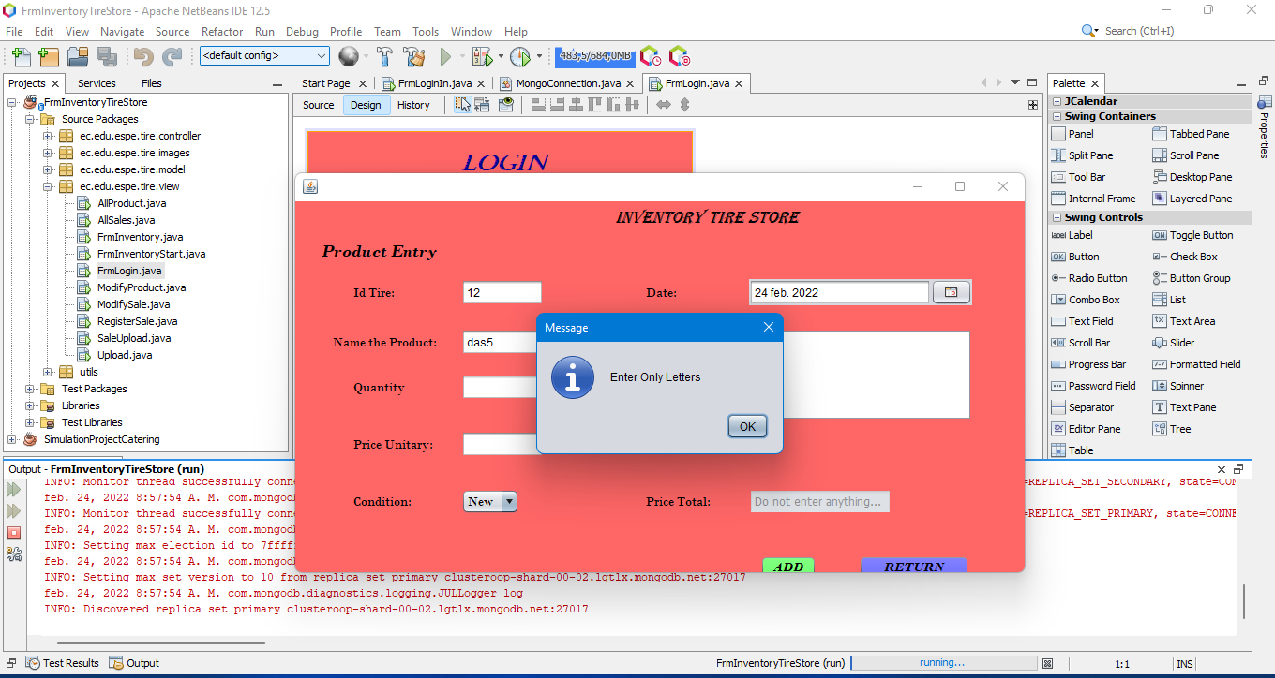

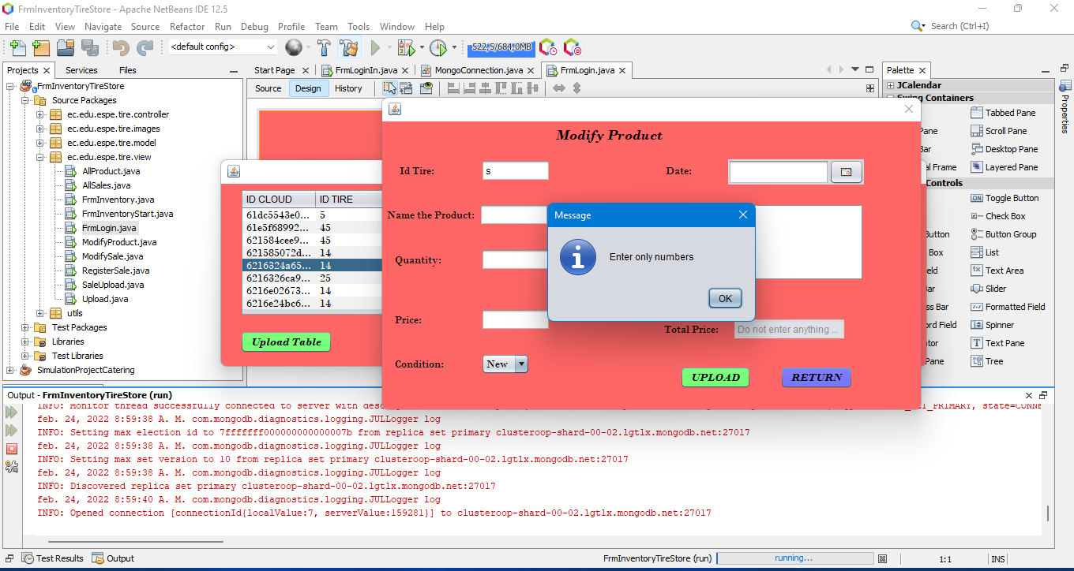

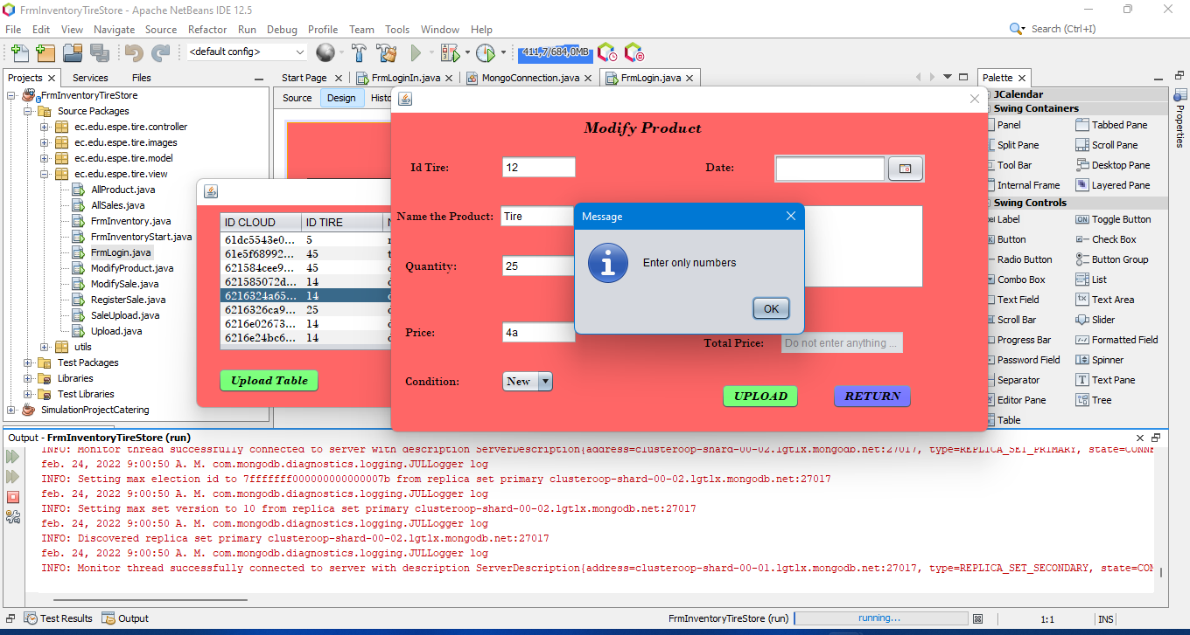

**Functionality**

It is OK

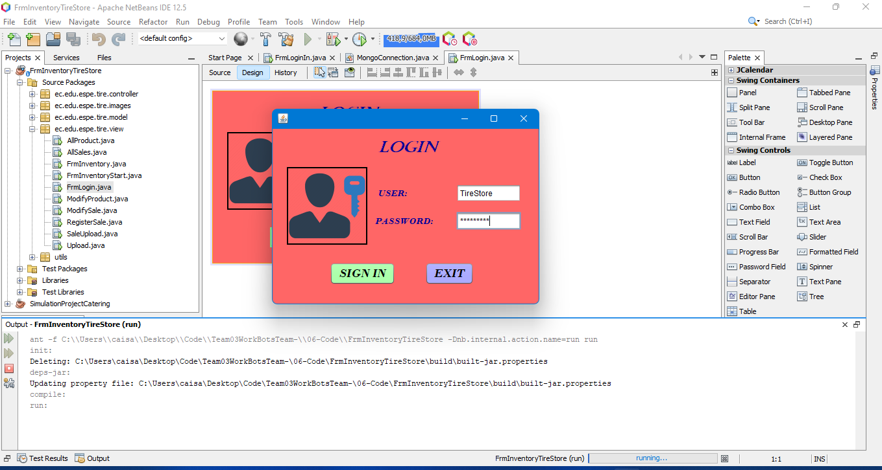

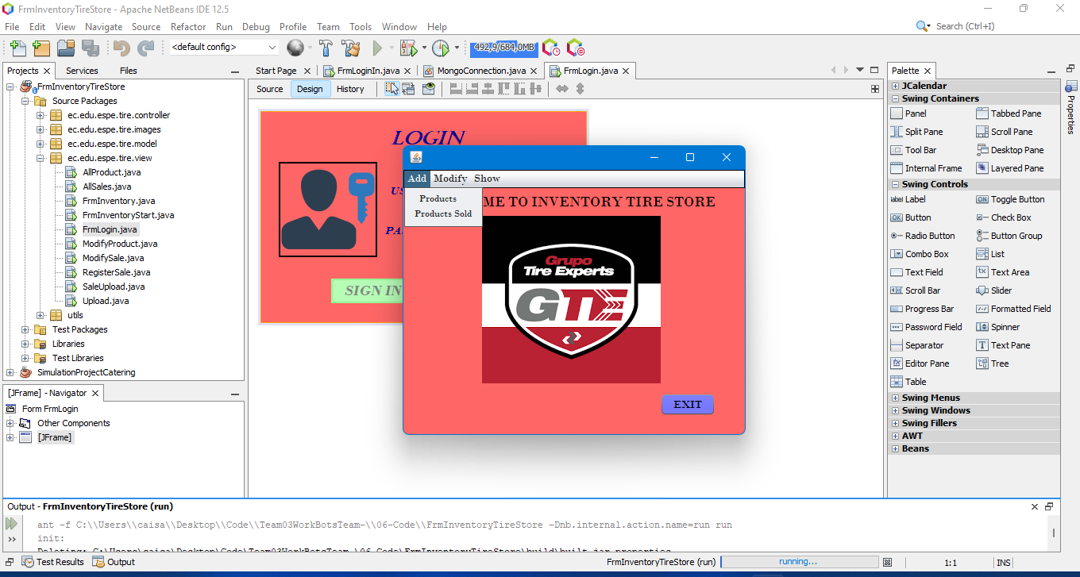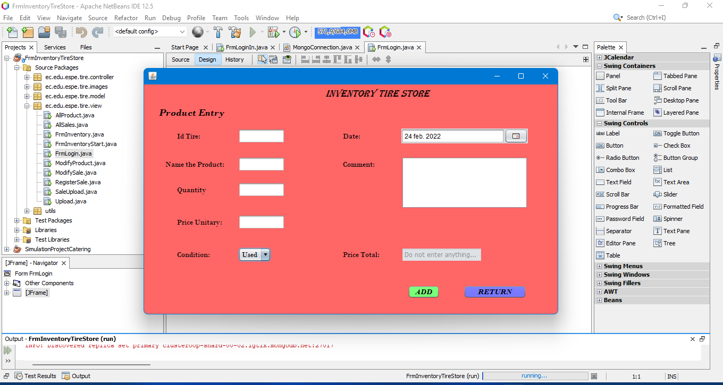

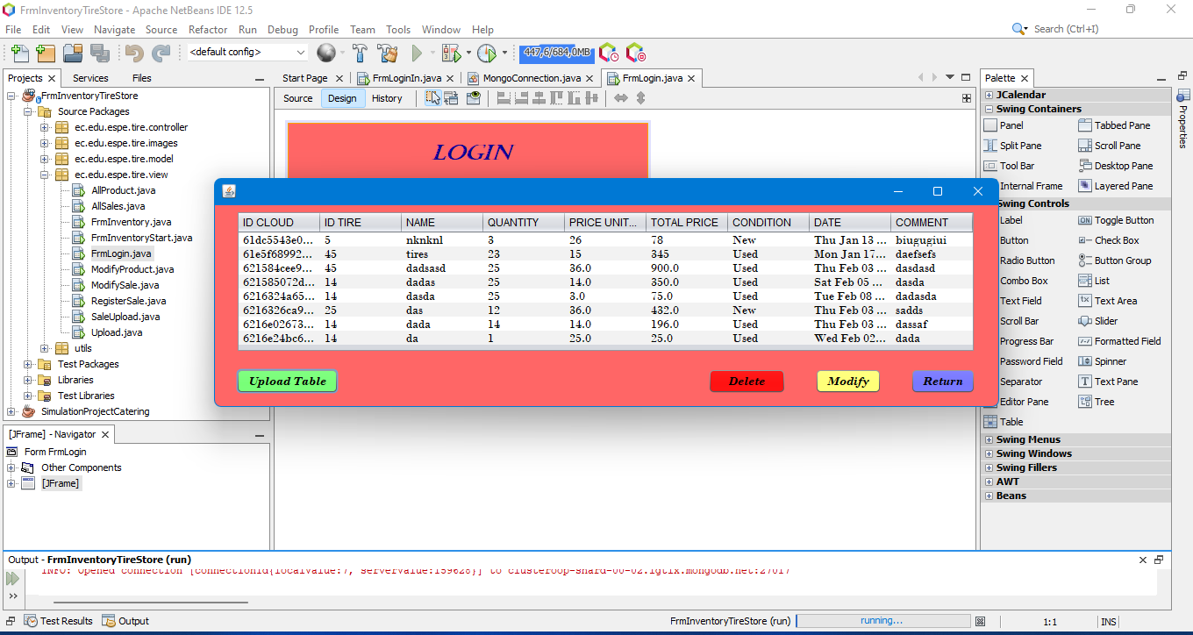

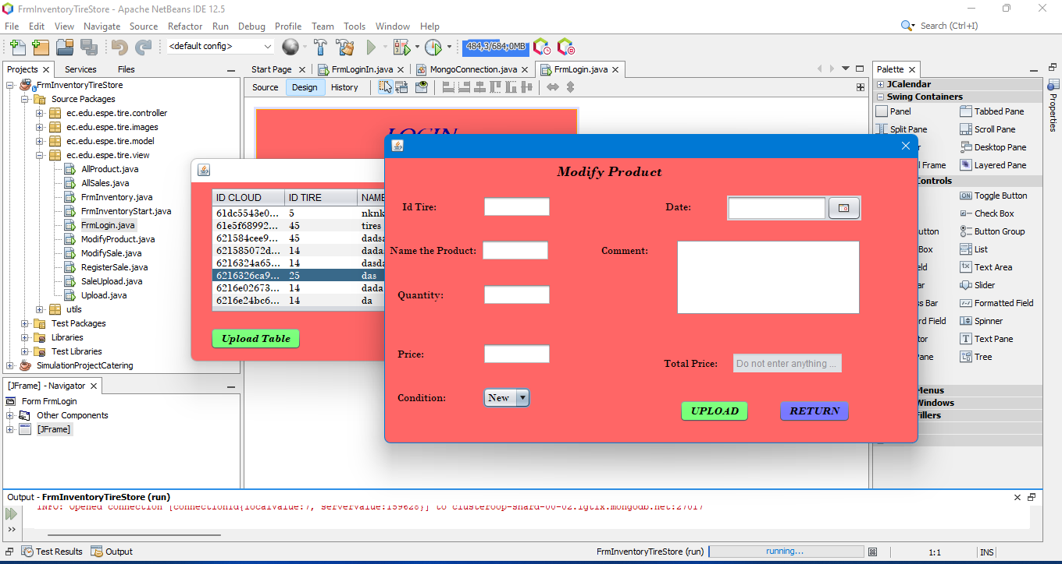

**MongoDB**

The connection with DB is OK.

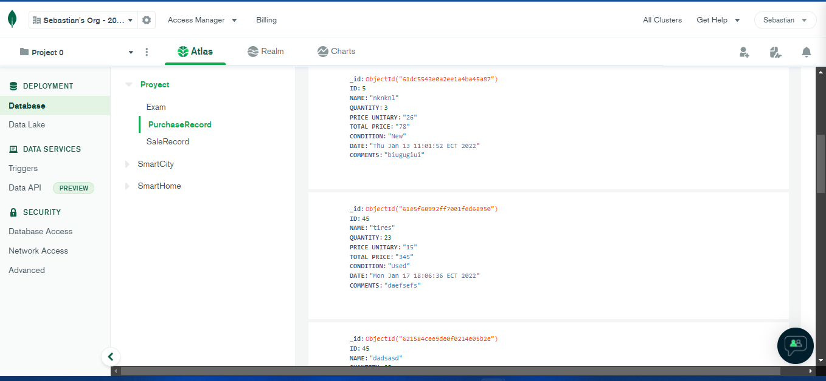

Inspector: T8 (Rocket Team) Leader: Alan Shuguli

Team: T4 (The ½ java programmer) Leader:Alejandro De la Cruz

Project: Inventaryshop3

Video: https://www.youtube.com/watch?v=UtOXQd4pSPM

16 DE LA CRUZ QUINGA ALEJANDRO SEBASTIAN

17 EIVAR DAGUA JAIME MAURICIO

18 GARCIA BARRETO MAYERLY PRISSILLA

19 GOMEZ DIAZ MELISSA MALAYCA

20 GUAMAN VEJARANO ANGEL DAVID

Modularity 10/10

Clean code 8.5/10

MVC 9/10

One design pattern 0/10

Diagrams consistency 8/10

Unit tests 5/10

GUI navigability 10/10

GUI fields validation 5/10

Functionality 9.5/10

MongoDB 10/10

______________________________

TOTAL 75 /100

Modularity

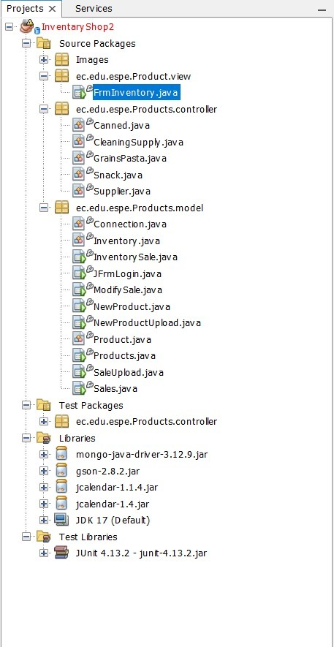

All ok, three packages created

Clean code

All Frm must go on the **view** of the project

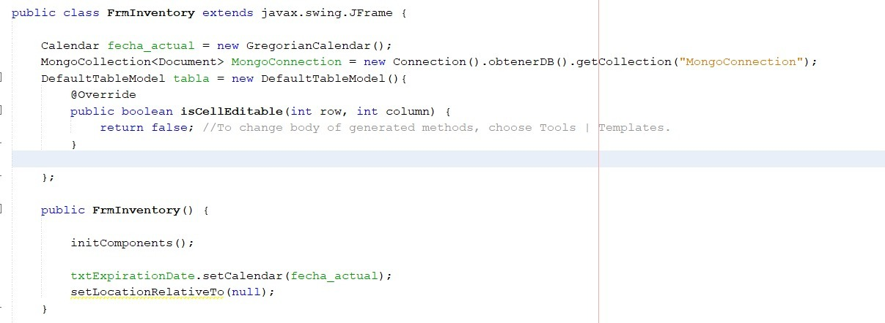

-Commented lines in the code

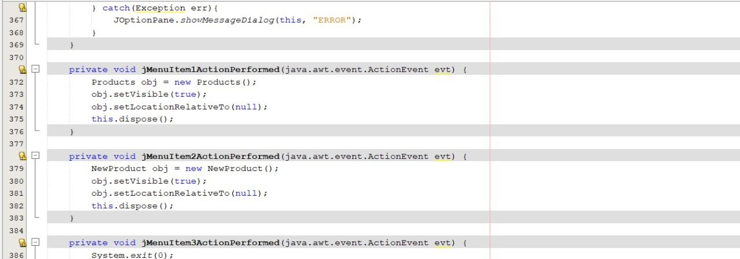

-Functions should be built outside of the buttons, and get called in it.

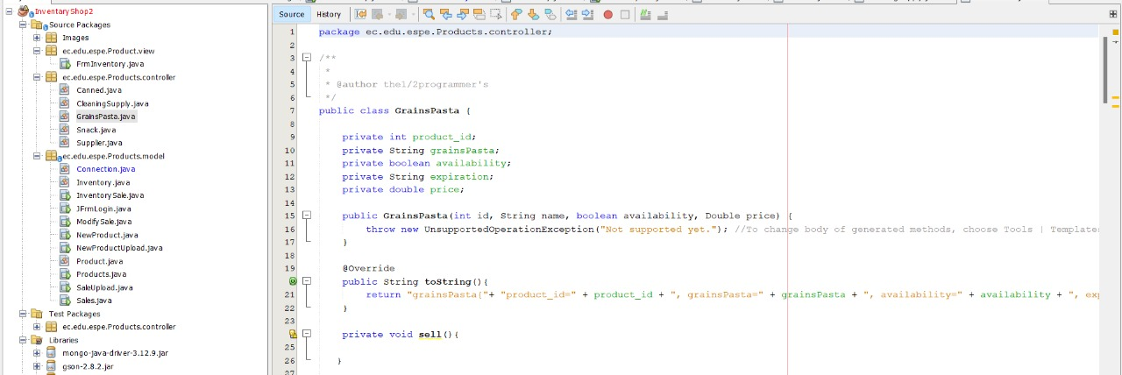

Attributes should be declared in lowerCamelCase,Error: (product_id)

MVC

**Controller:**

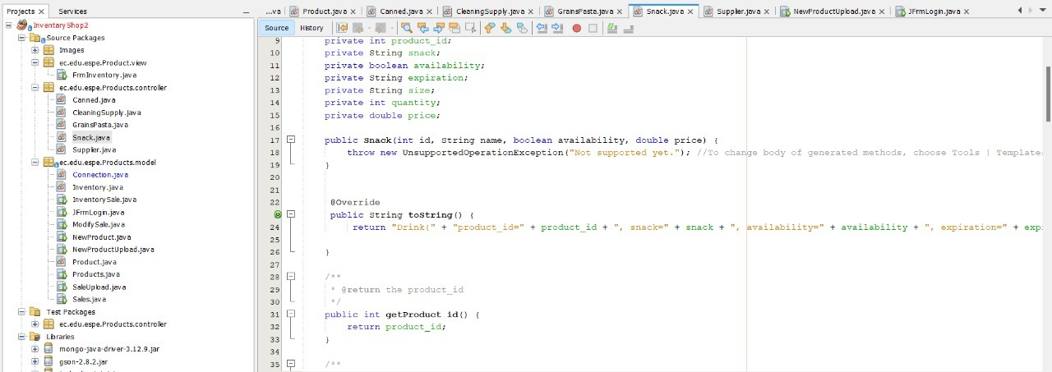

Everything Ok in the controller:

**Model:**

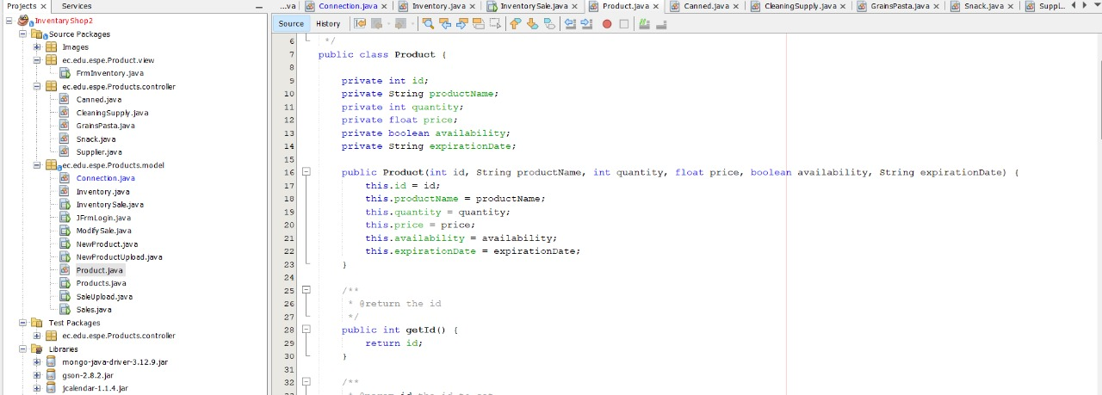

Classes have correct declaration, but Frm should go on **view** package

**View:**

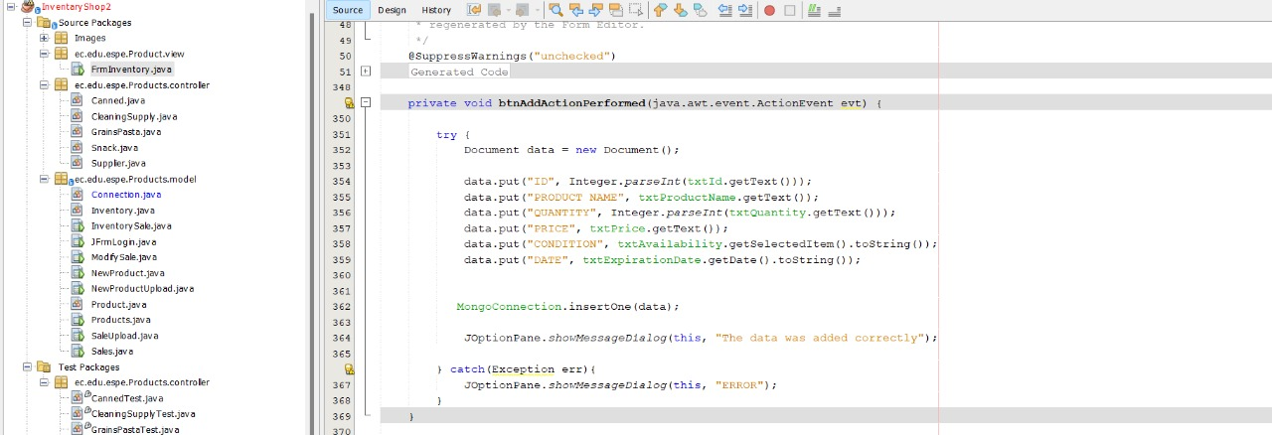

No code in the buttons, everything Ok

One design pattern:

There is no pattern

Diagrams consistency

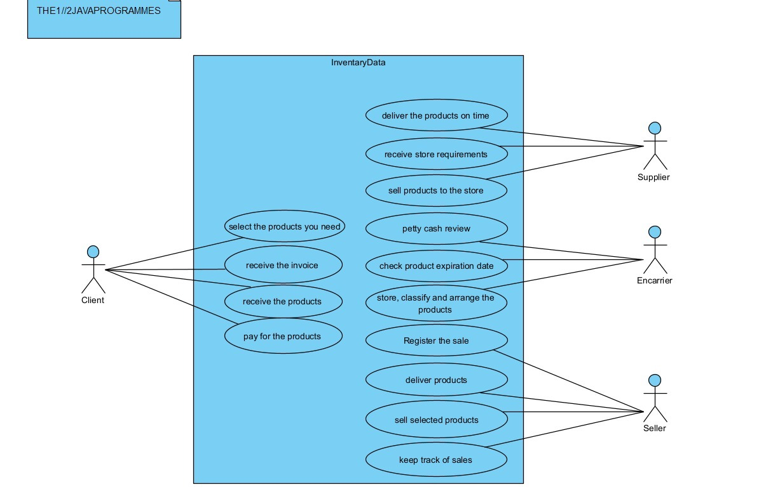

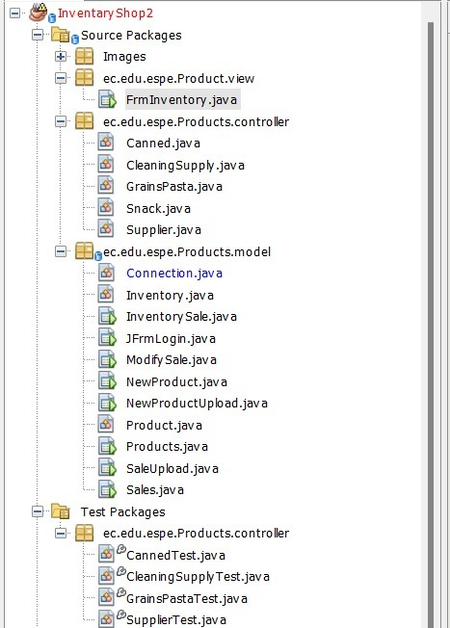 

-Use Case Diagram has more attributes than the Frm in the view packages.

-The Frm’s don’t use all the attributes of the classes

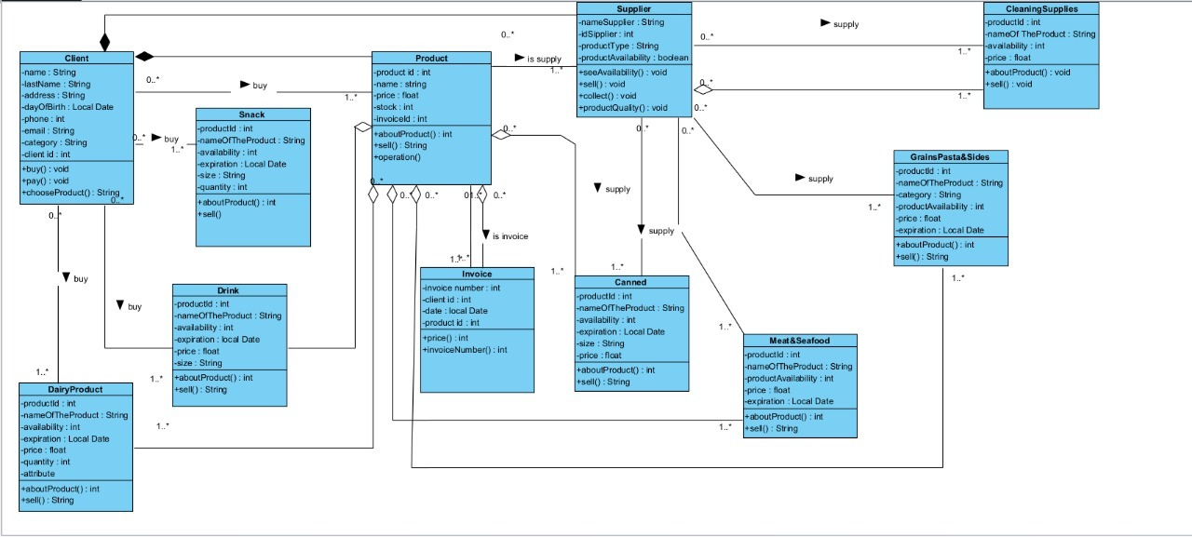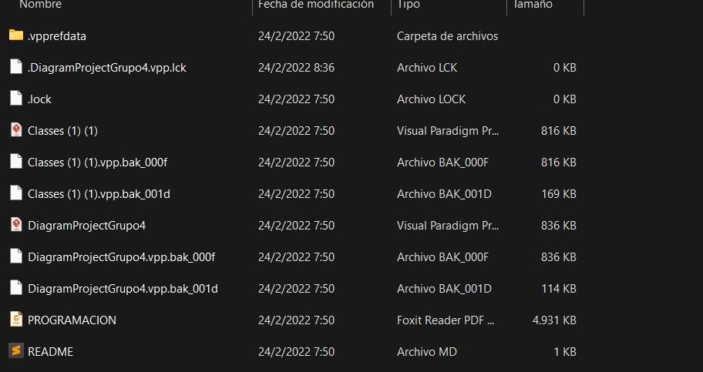

UML Diagram is consistent with the program, but there is a lot of garbage data in the file of the UML diagram

Unit tests

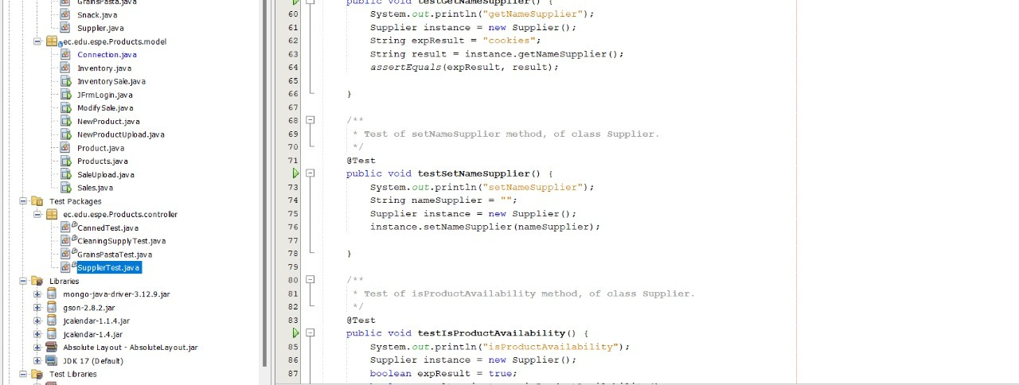

GUI navigability

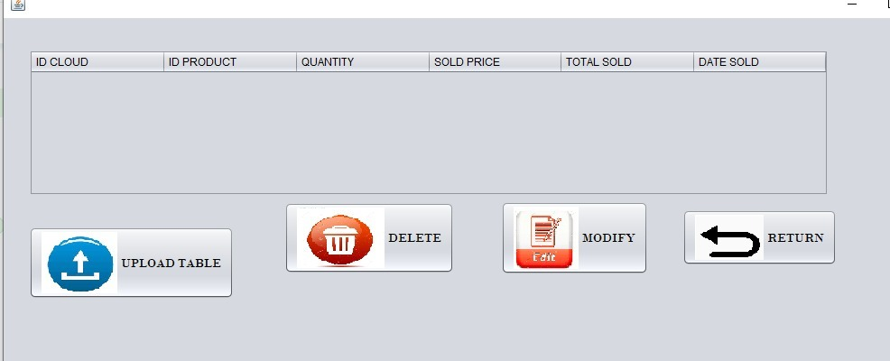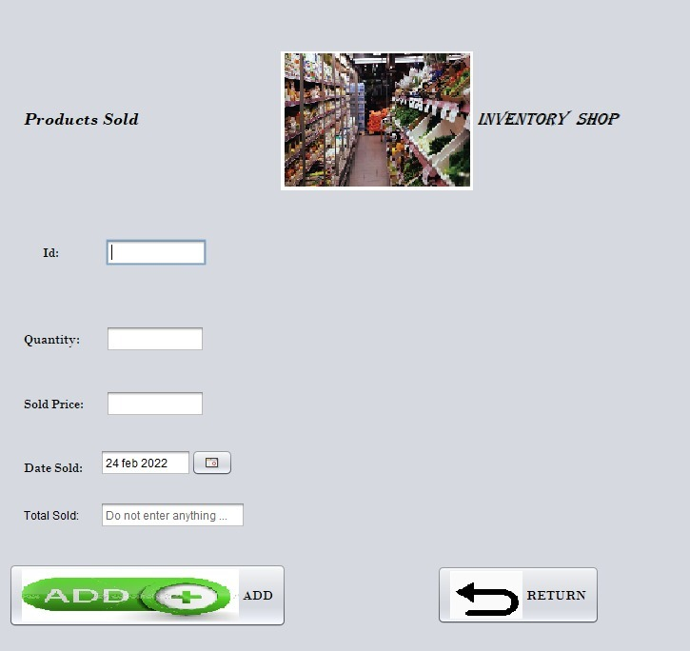

GUI fields validation

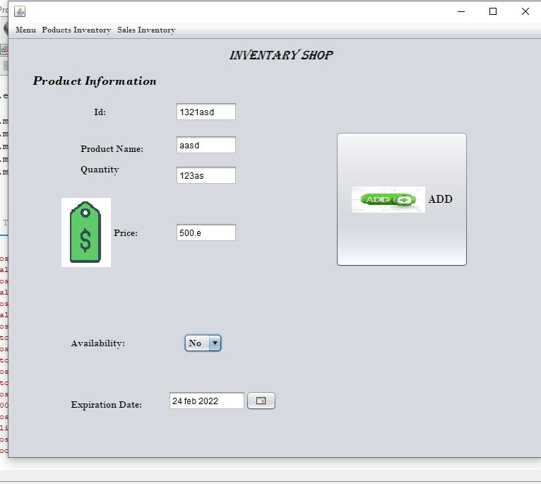

Functionality

MongoDB

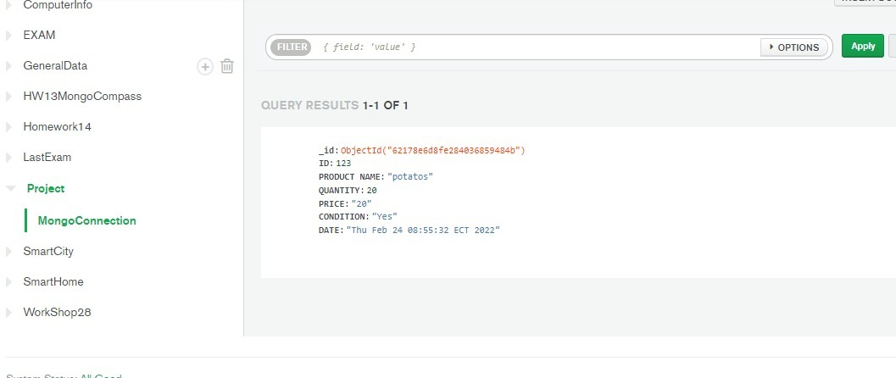

Inspector: T4(The ½ java programmer ) Leader:De la Cruz Alejandro

Team: T5 (JavaLegends) Leader. Guitarra Jhon

Project: MedicalPro

21 GUITARRA SANCHEZ JHON ALEXANDER

22 GUZMAN LOPEZ JOSE DAVID

23 INSUASTI LOPEZ JONATHAN ESTEBA

24 LANDAZURI SEGOVIA MATEO ISRAEL

25 LINCANGO CRIOLLO JOSE DANIEL

Modularity 9/10

Clean code 8/10

MVC 10/10

One design pattern 0 /10

Diagrams consistency 7.5/10

Unit tests 10/10

GUI navigability 9/10

GUI fields validation 0/10

Functionality 10/10

MongoDB 10/10

______________________________

TOTAL 73.5/100

**MODULARITY**

*It has a package of more than one, it does not comply with the concept of modularity.

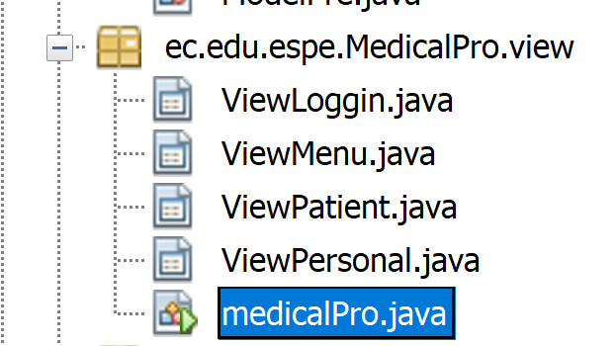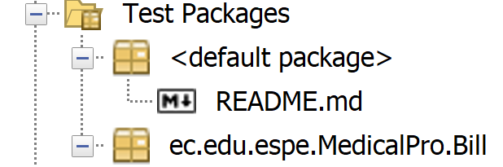

**CLEAN CODE**

* The names of the classes are not understandable, does not comply with the concept of clean code

* The medical pro class is not in the package it should be.  
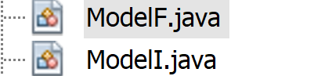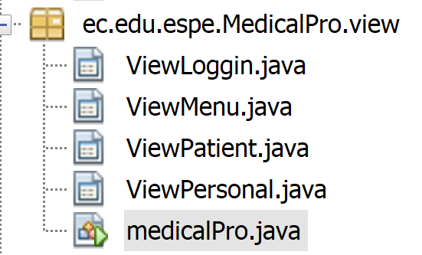

**MODEL, CONTROLLER AND VIEW**

All is it ok.

**ONE DESIGN PATTERN**

DOES NOT HAVE

**DIAGRAMS CONSISTENCY**

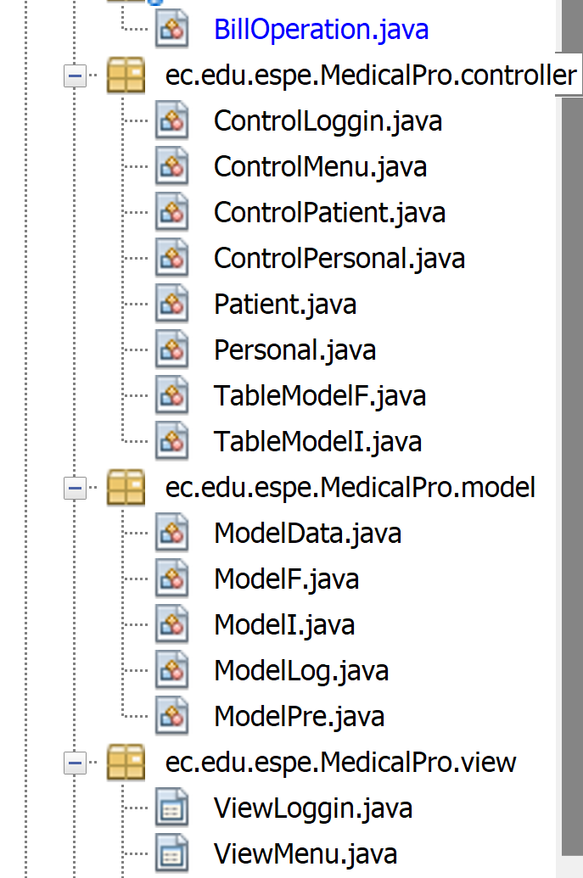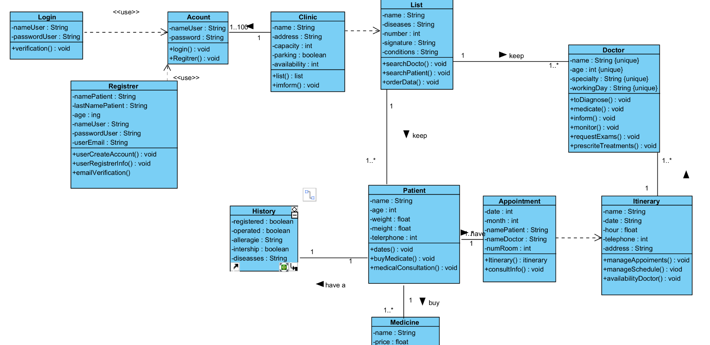

**UNIT TEST**

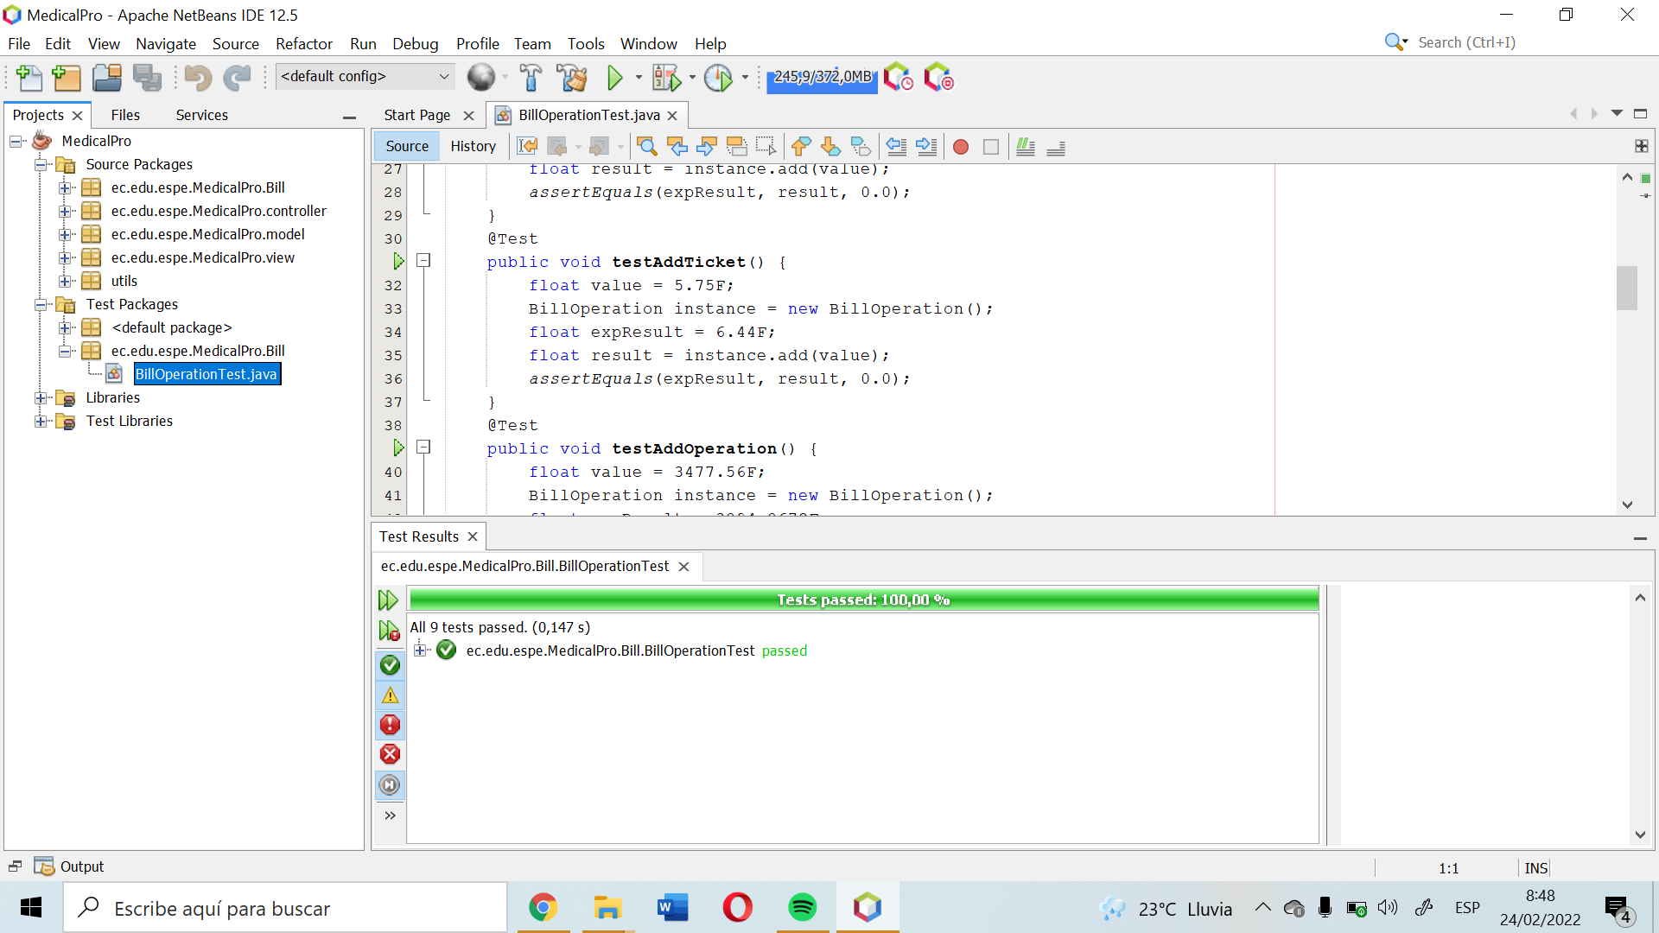

**GUI NAVIGABILITY**

its Ok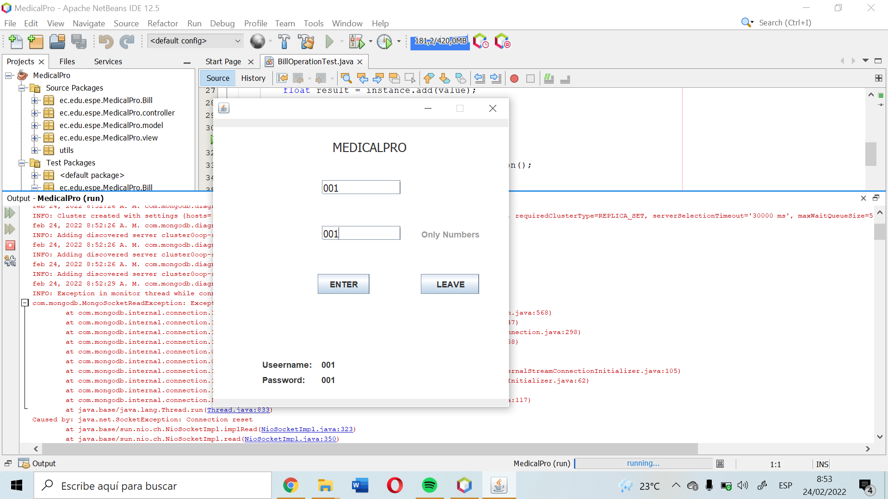

*Error inconsistency

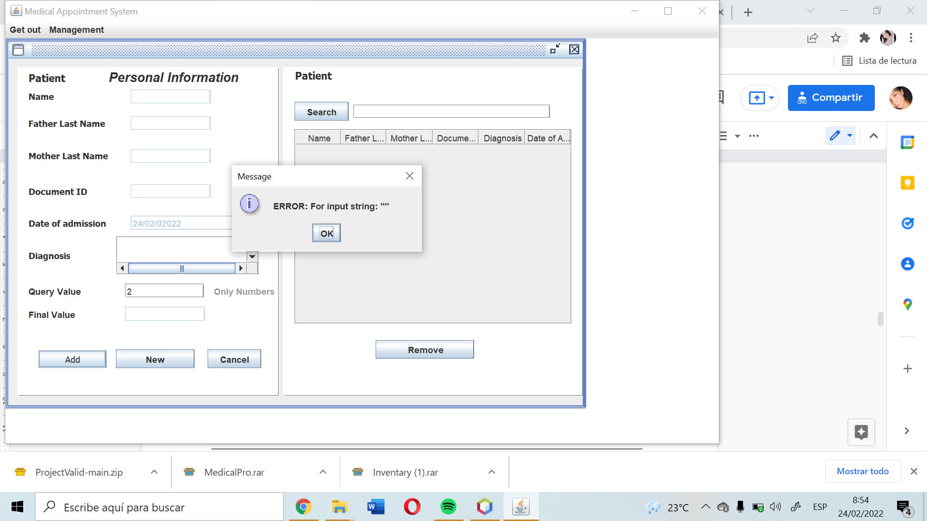

**GUI FIELDS VALIDATION**

*all right, if you add the data

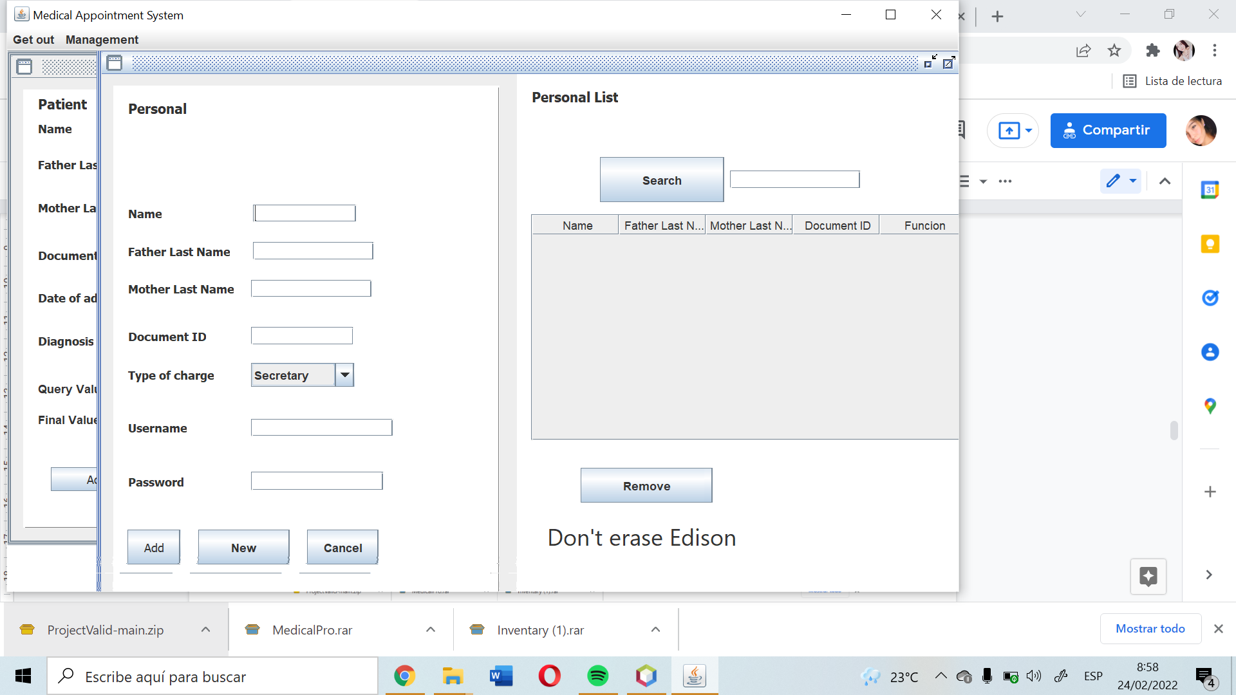

_________________________________________________________________________

Inspector: T2(BigBoysTeam) Leader Pablo Bustillos

Team: T6 (ProJavaDevelopers) Leader: Leonel Mantuano

Project: Application Of Human Resources

26 MAISINCHO PAUCAR RICHAR ALEXANDER

27 MALDONADO BASTIDAS MATEO STEFANO

28 MANTUANO FERNANDEZ LEONEL FERNANDO

29 MORALES CAICEDO ANTHONY JAVIER

30 PALACIOS CANDO DIEGO SEBASTIAN

Modularity 9/10 Controller is missing.

Clean code 8/10 Variables, comments in lines of code.

MVC 9/10 The model and the view are fine, but the controller is missing.

One design pattern 0/10 Does not apply One design pattern.

Diagrams consistency /10

Unit tests 0/10 Does not apply Unit tests.

GUI navigability 10/10 It's okay

GUI fields validation 10/10

Functionality 10/10

MongoDB 10/10

______________________________

TOTAL 56/100

**Modularity**

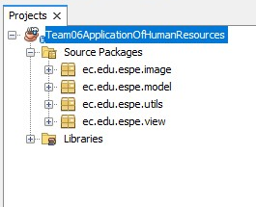

Clean code

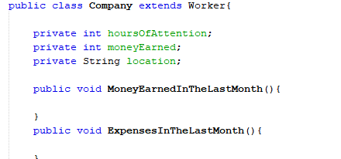

The name of the classes is not very well understood and does not comply with the clean code

Comments on lines of code





Don't comment lines of code

**MVC**

MODEL

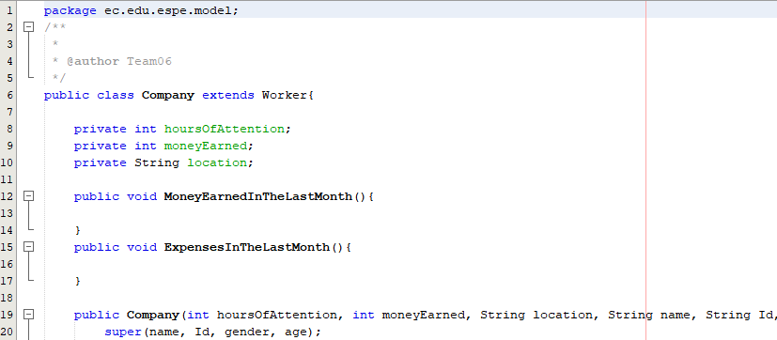

**CONTROLLER**

Controller is missing

**VIEW**

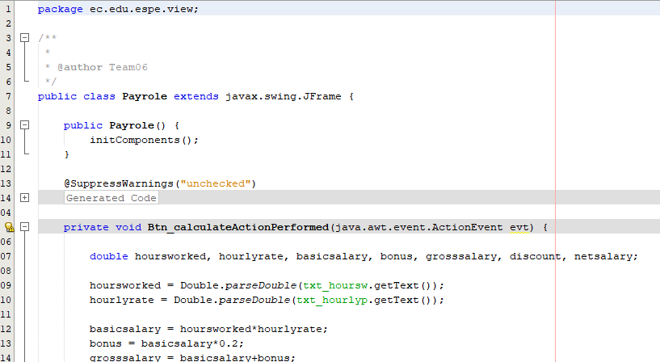

**One design pattern**

Does not apply One design pattern.

**Diagrams consistency**

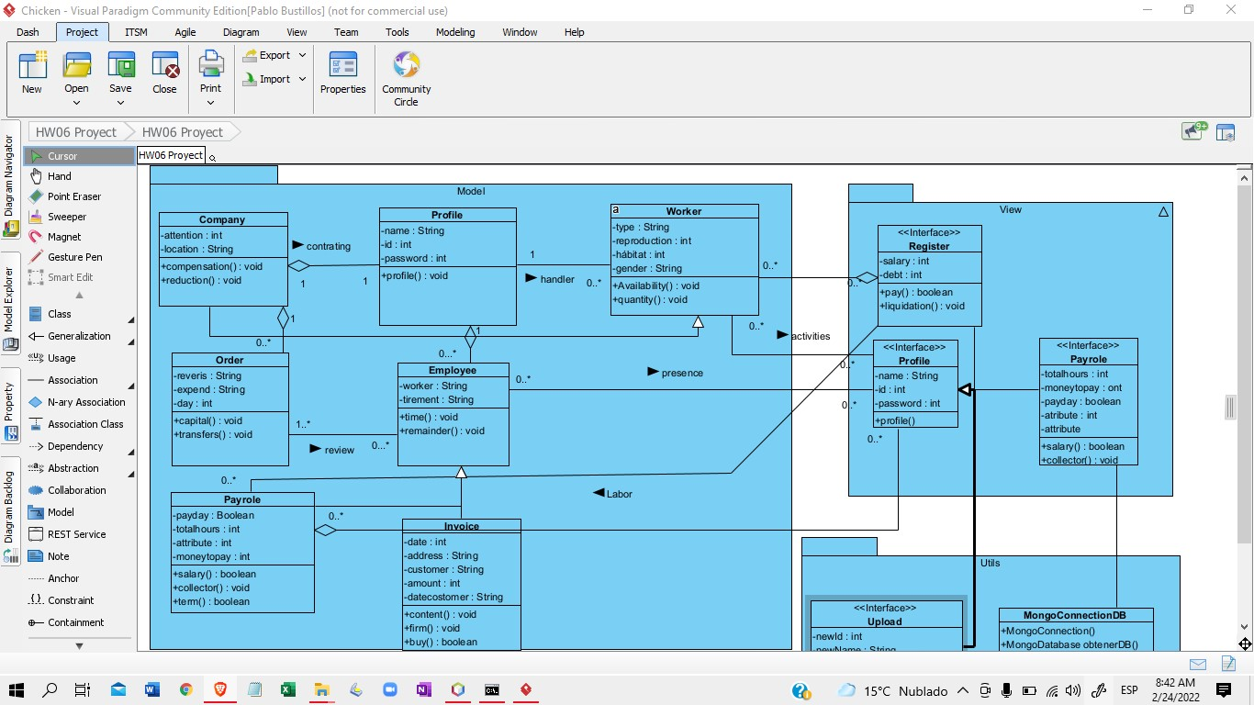

**Unit tests**

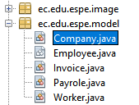

Does not apply Unit tests

**GUI navigability**

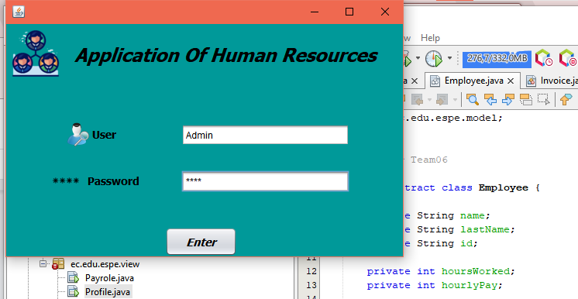

It's okay

**GUI fields validation**

**Functionality**

**MongoDB**

________________________________________________________________________

Inspector: T9: (No Leader Team) Leader: Zeas Joel

Team: T7: (Project X) Leader: Ruano Alexander

Project : Project x Warehouse

31 PAUCAR LEMA ALEX JAVIER

32 QUINGA GUAYASAMIN LEANDRO ALEXANDER

33 RUANO PONCE ALEXANDER JAVIER

34 SALTOS TACO PAUL ALEXANDER

35 SANCHEZ MISHQUERO JOSE FRANCISCO

Review Video Link: <https://youtu.be/8nRUEKXfHIY>

Modularity 10/10

Clean code 9.5/10

MVC 8/10

One design pattern 0/10

Diagrams consistency 10/10

Unit tests 6/10

GUI navigability 10/10

GUI fields validation 10/10

Functionality 10/10

MongoDB 10/10

______________________________

TOTAL 83.5 /100

Modularity All packages are correctly distributed

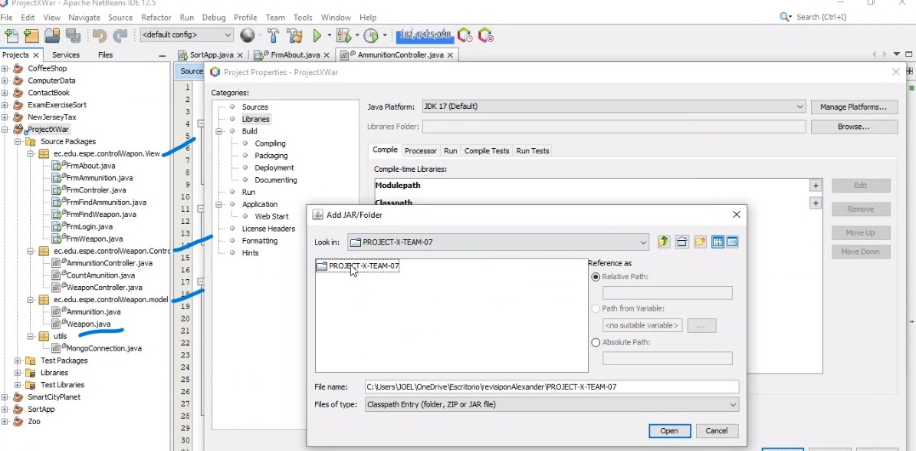

Clean code There's unnecessary comments, do not use camelCase

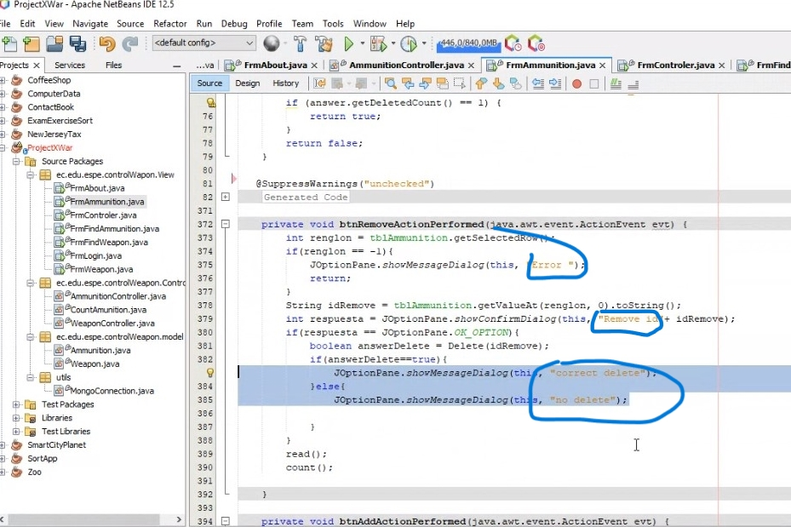

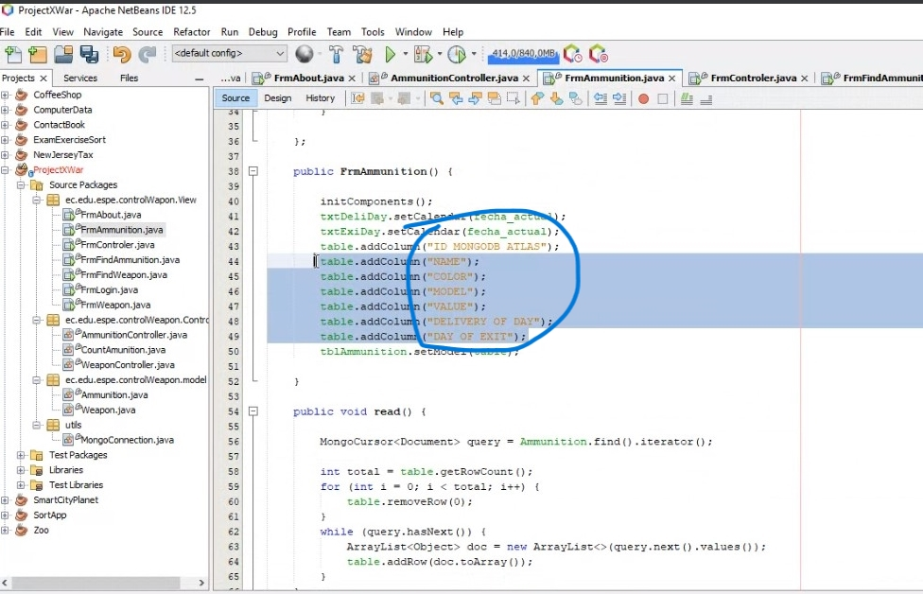

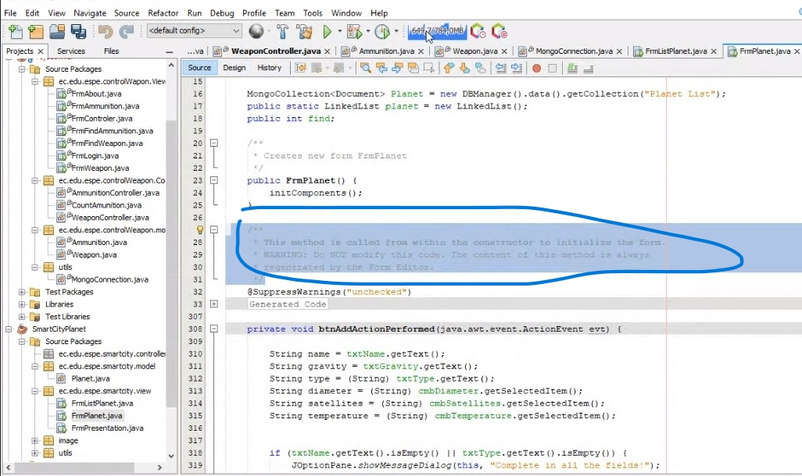

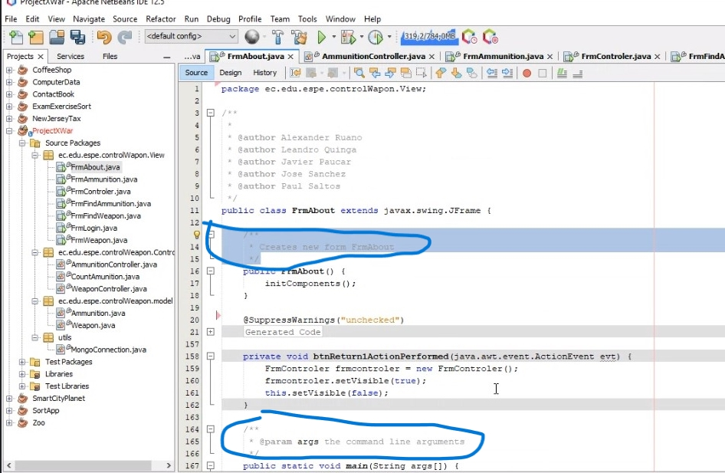

MVC Connection code in the controller package

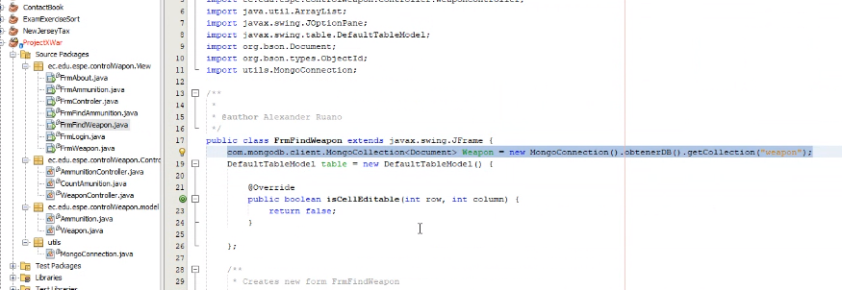

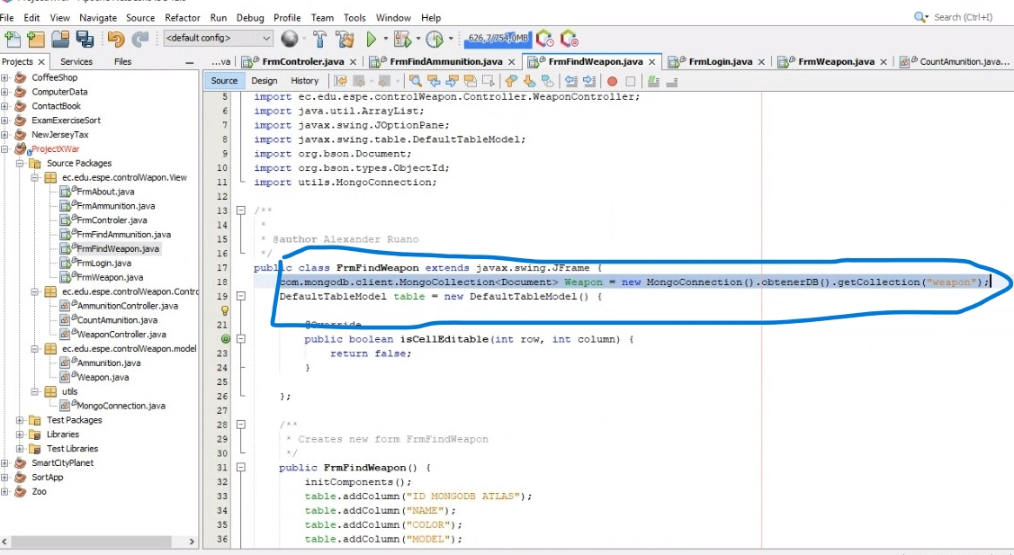

One design pattern There´s not design pattern

Diagrams consistency All the diagrams are correct

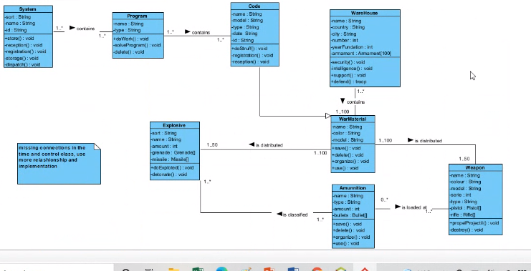

Unit tests It needs more unit tests

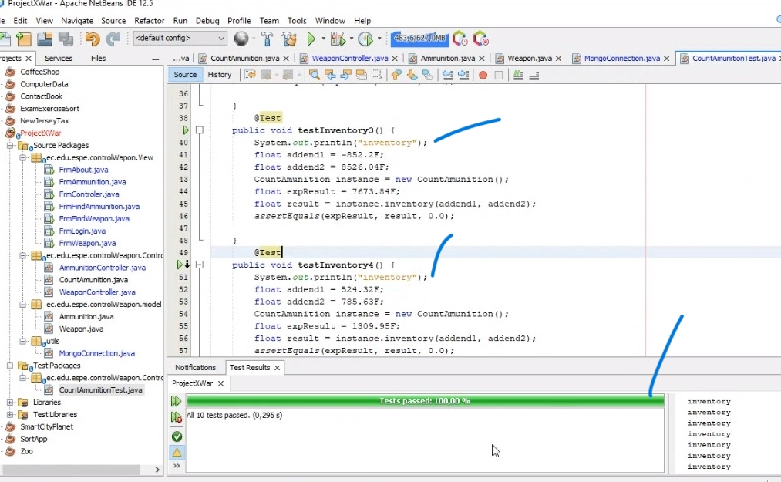

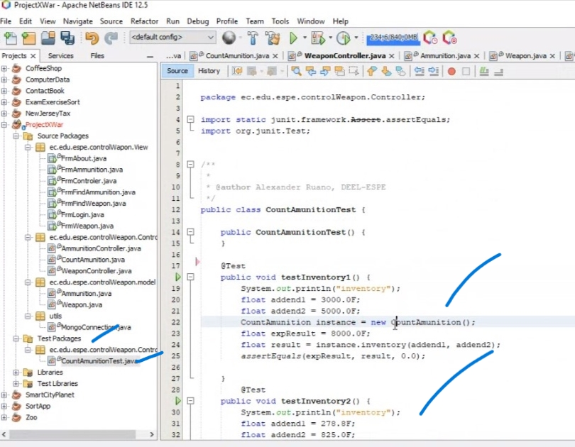

GUI navigability All correct

GUI fields validation All the text fields are validated

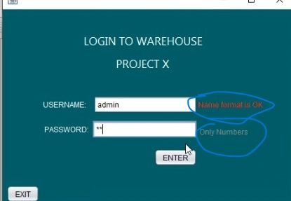

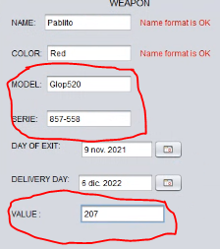

Functionality All correct

MongoDB The connection with the database is correct

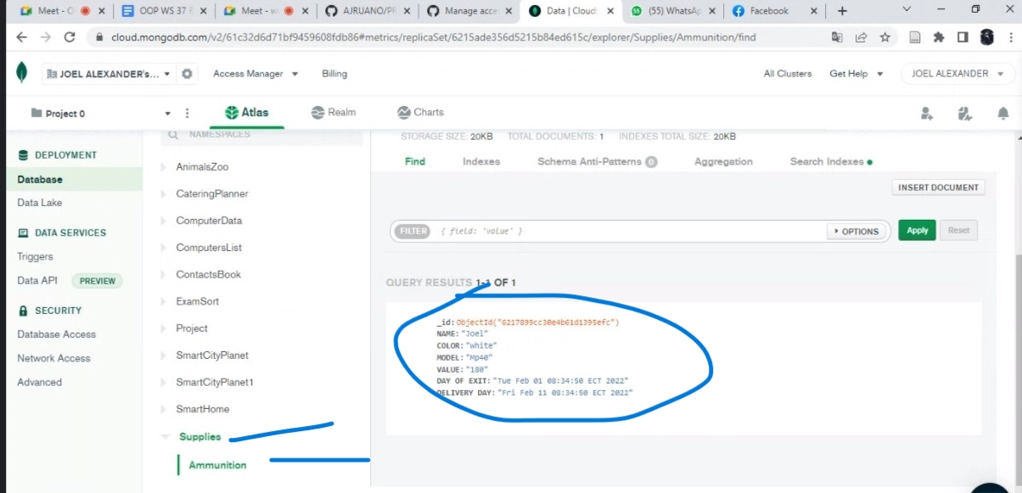

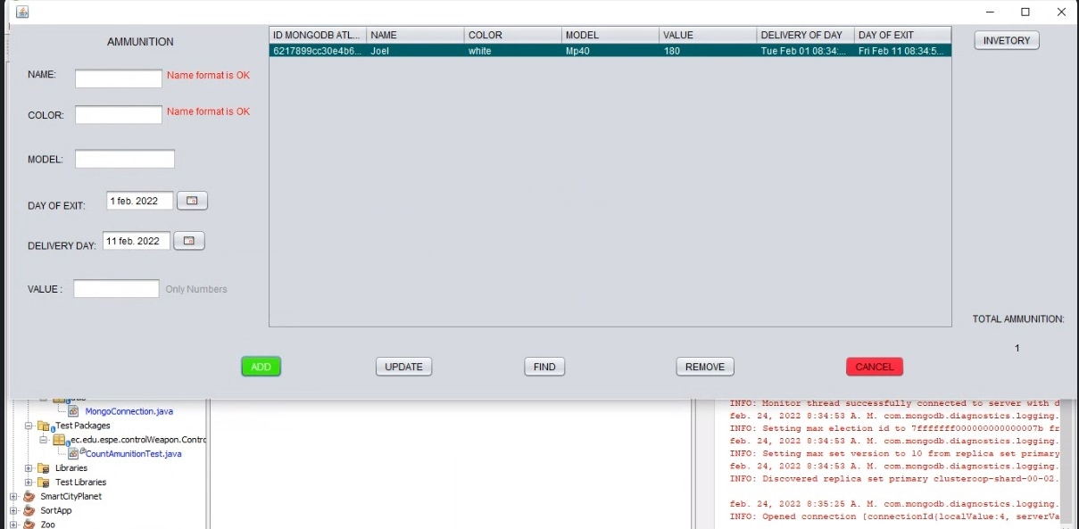

________________________________________________________________________

Team: T6 (ProJavaDevelopers) Leader: Leonel Mantuano

Team: Project: T8:(RocketTeam) Leader: Alan Shuguli

sin nombre de proyecto

36 SHUGULI REINOSO ALAN JESITH

37 SIMBAÑA SIMBAÑA JONATHAN GUSTAVO

38 TAPIA ALBAN ANDREA JULIANNA

39 TAYO RUIZ SEBASTIAN ALEJANDRO

40 TECA TELLO CAMILA MILENA

Modularity 9/10

Clean code 9/10

MVC 8/10

One design pattern 10/10

Diagrams consistency 8/10

Unit tests 2/10

GUI navigability 9/10

GUI fields validation 9/10

Functionality 10/10

MongoDB 10/10

______________________________

TOTAL 84 /100

Video: <https://youtu.be/OfIyTMYa23U>

Modularity

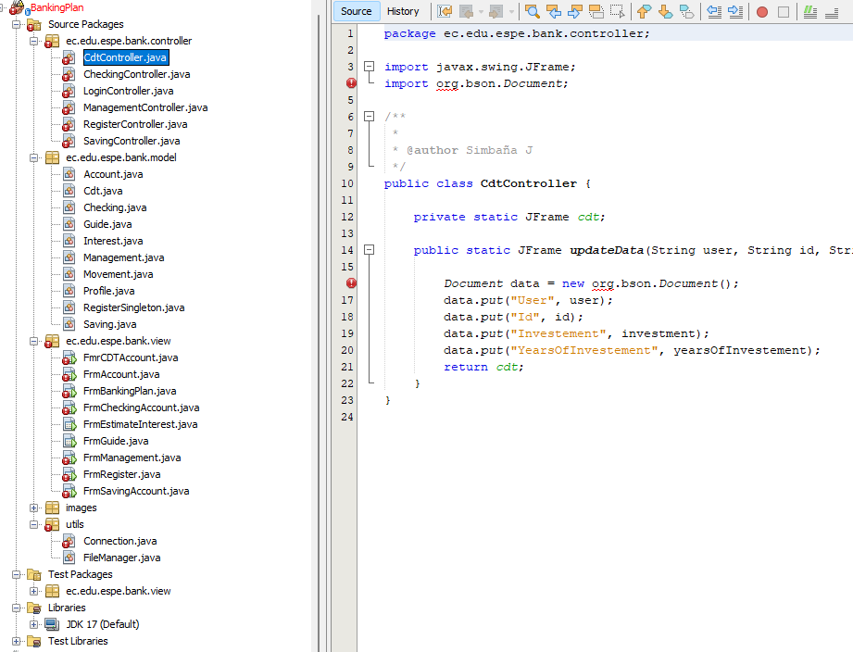

Clean code

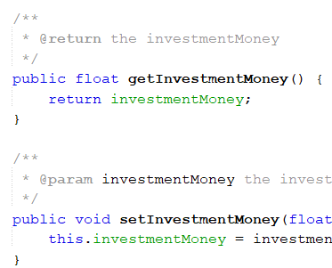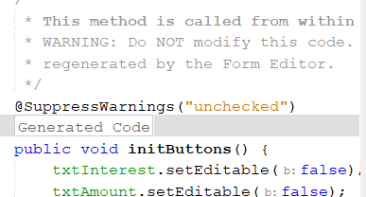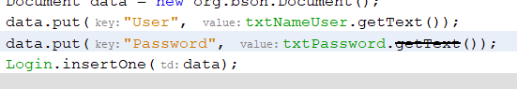

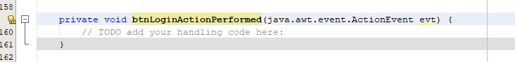

button does not call function

**MVC**

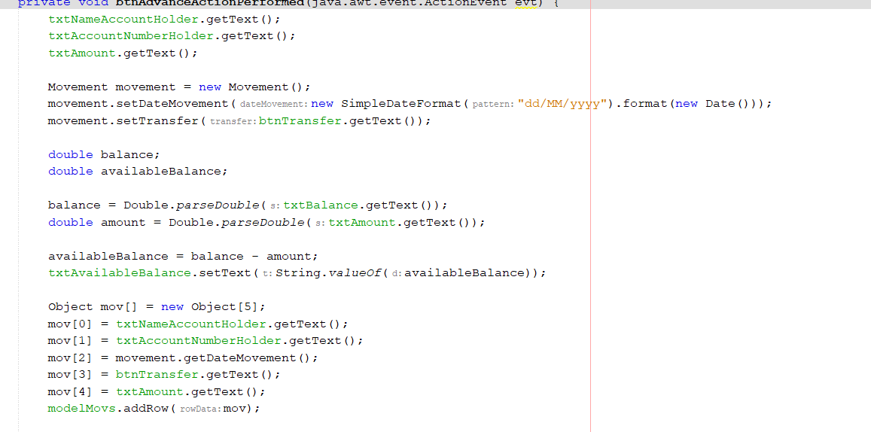

* Code in the btn

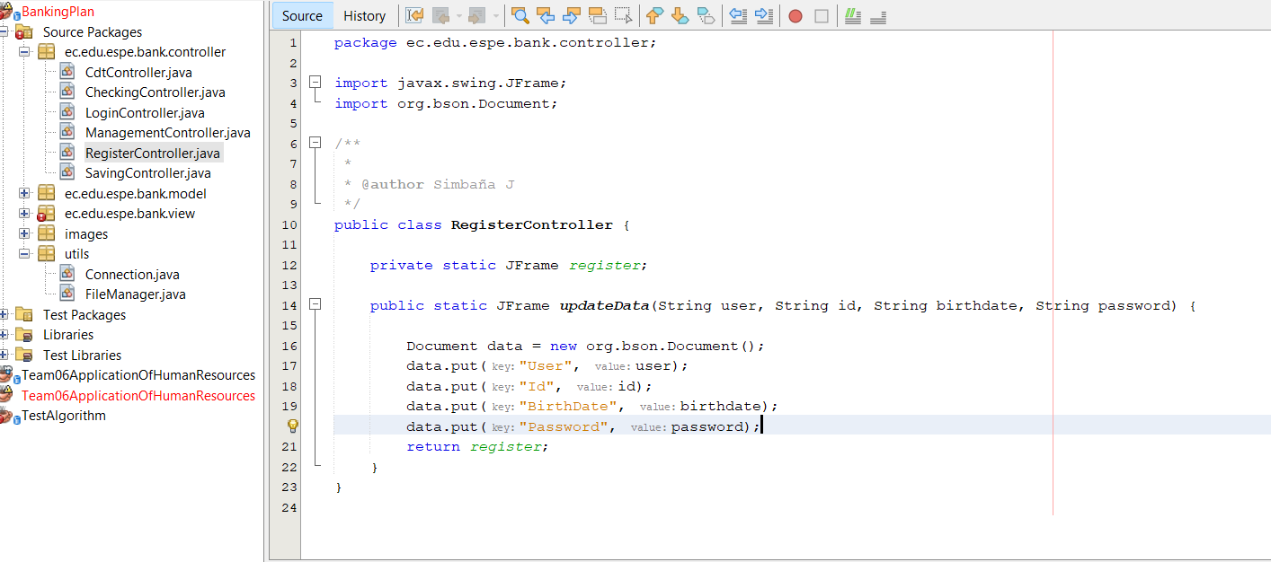

**One design pattern**

* Singleton

**Diagrams consistency**

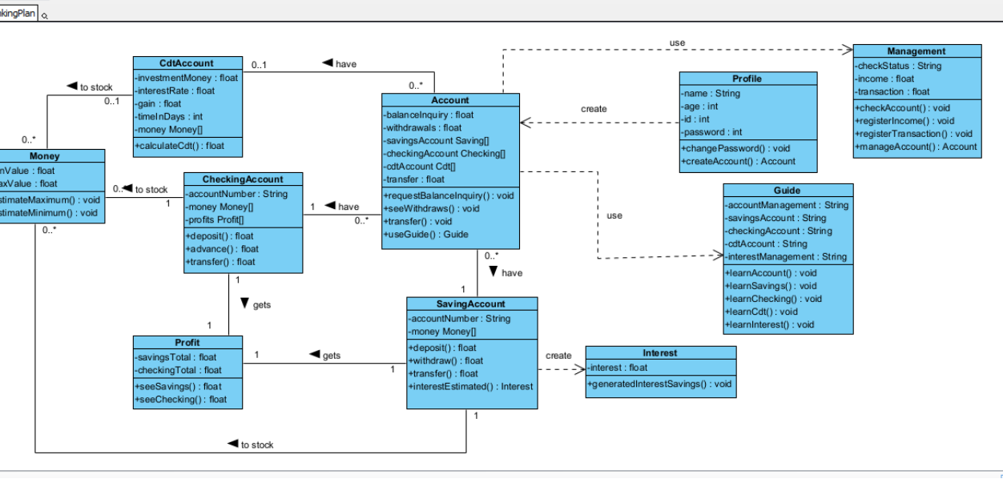

* Missing packages

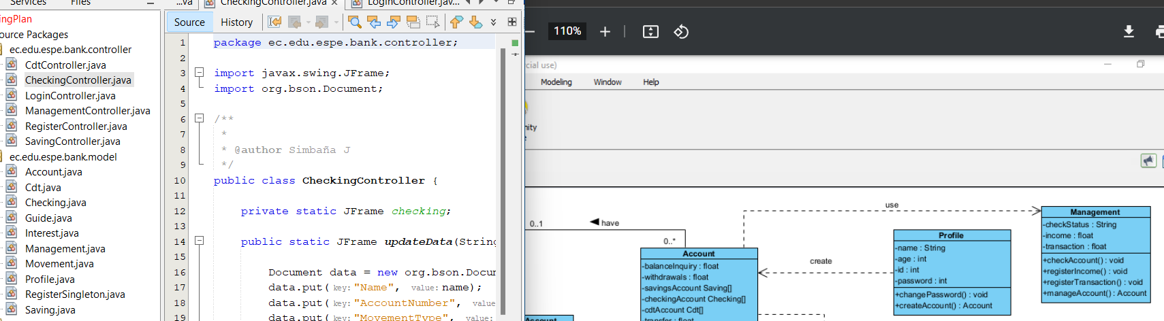

* Lack of classes and connections

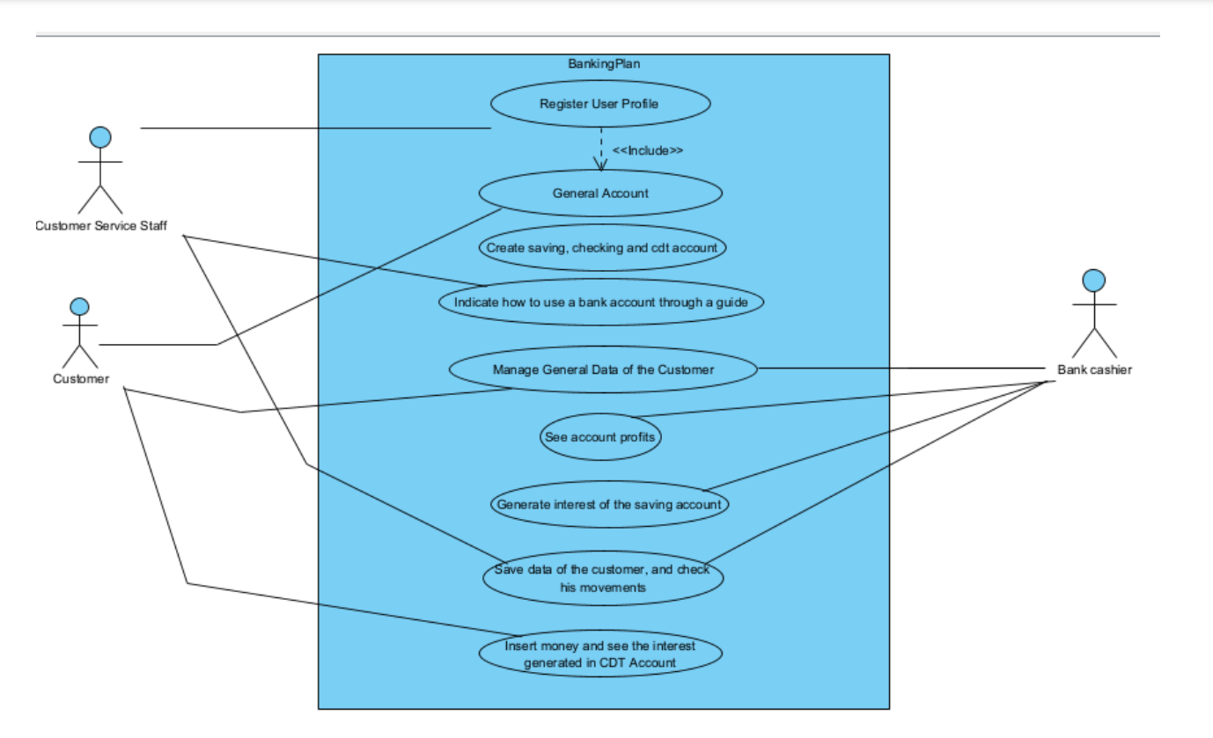

**Unit tests**

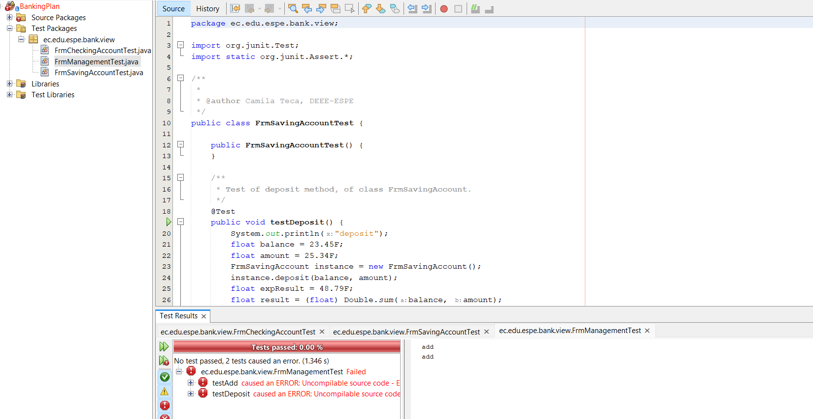

**GUI navigability**

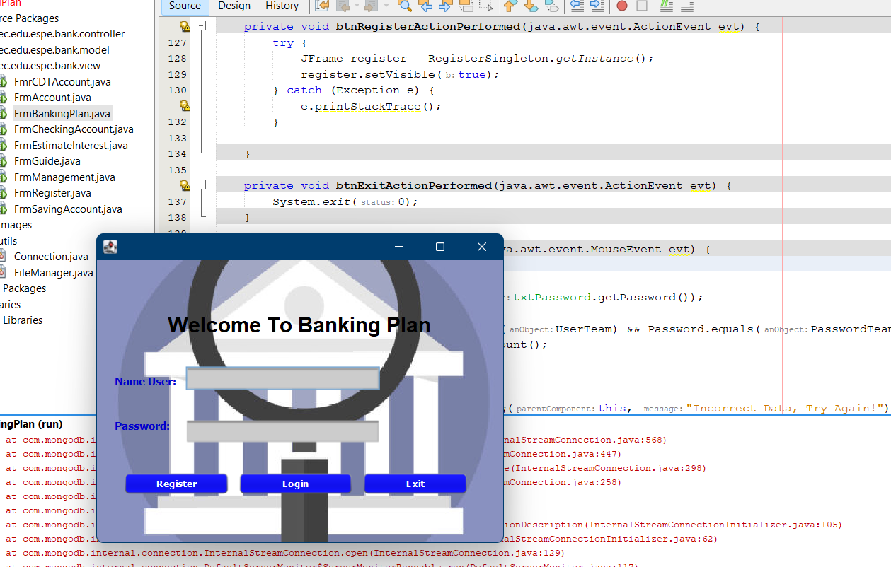

**GUI fields validation**

**Functionality**

**MongoDB**

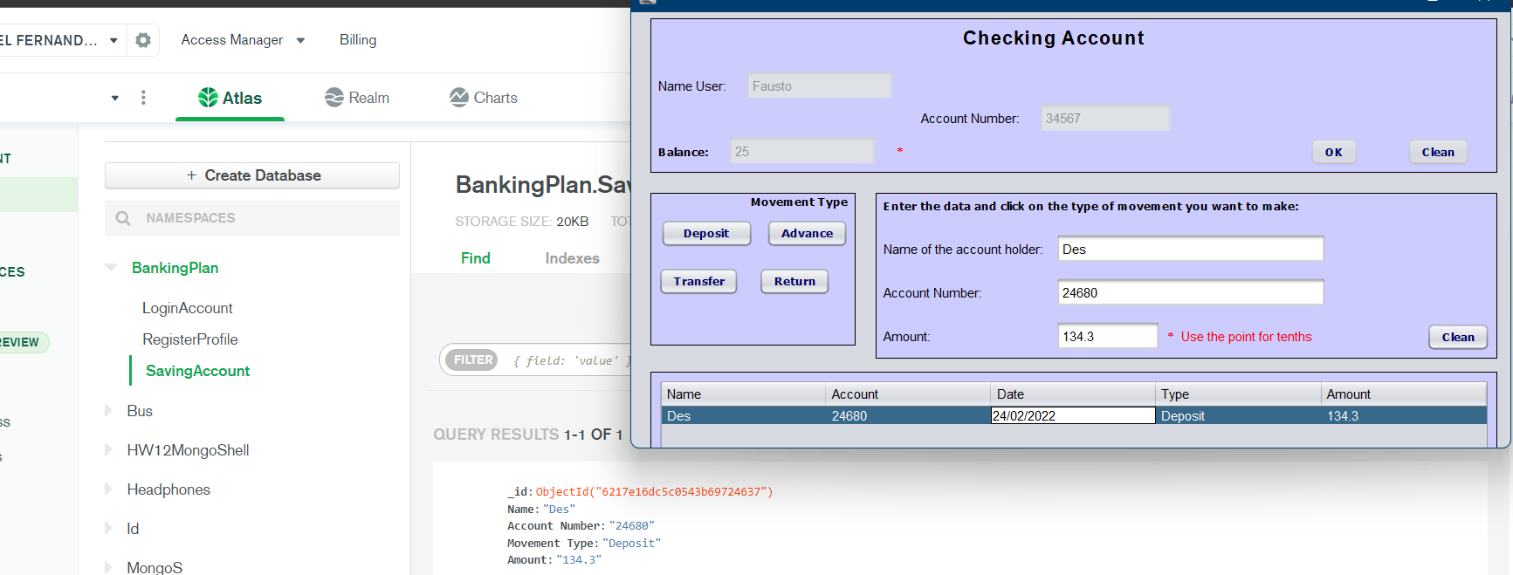

_________________________________________________________________________

Inspector: T3: (TeamWorkBots) Leader: Andy Calderon

Team: T9 (No Leader Team) Leader: Zeas

Project: Catering Planner

41 TERAN FLORES MELANIE ELIZABETH

42 VILLEGAS ESTRELLA SALMA ABIGAIL

43 ZEAS CLAVIJO JOEL ALEXANDER

Modularity 9/10 (no controller package)

Clean code 9/10 (commented code)

MVC 8/10

One design pattern 0/10

Diagrams consistency 10/10

Unit tests 10/10

GUI navigability 10/10

GUI fields validation 9/10

Functionality 10/10

MongoDB 10/10

______________________________

TOTAL 85 /100

**Modularity**

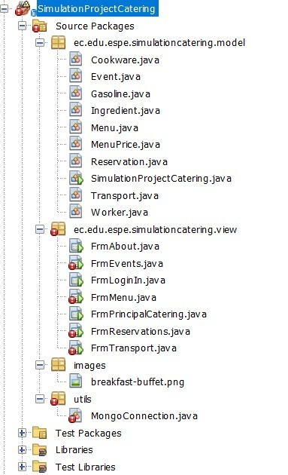

It is well distributed but missing controller package

**Clean code**

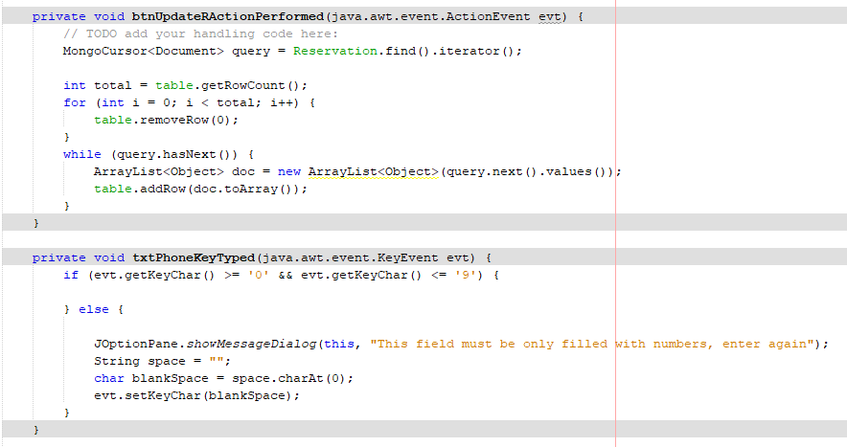

it has code on the buttons

**MVC**

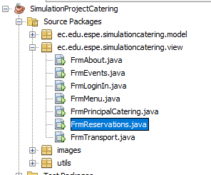

No controller package

**One design pattern**

No exist

**Diagrams consistency**

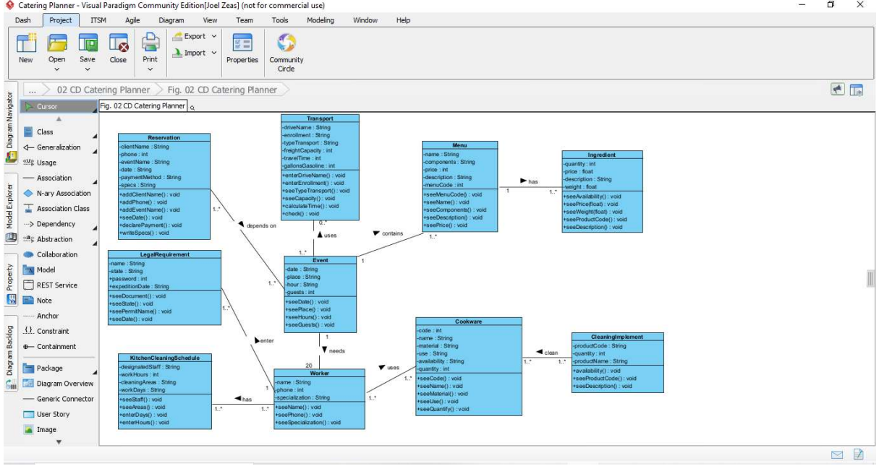

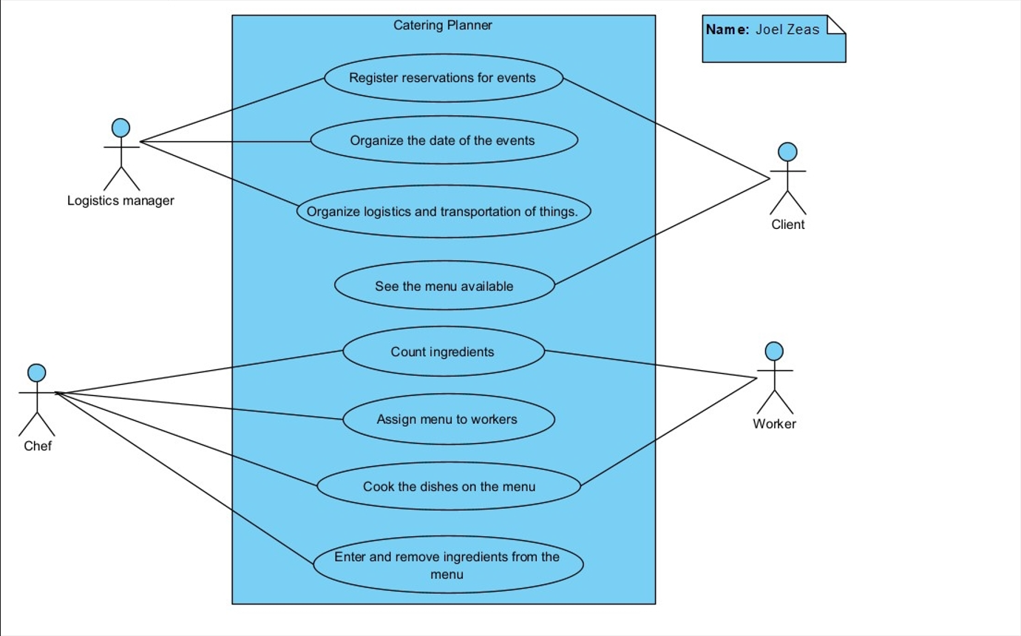

**Unit tests**

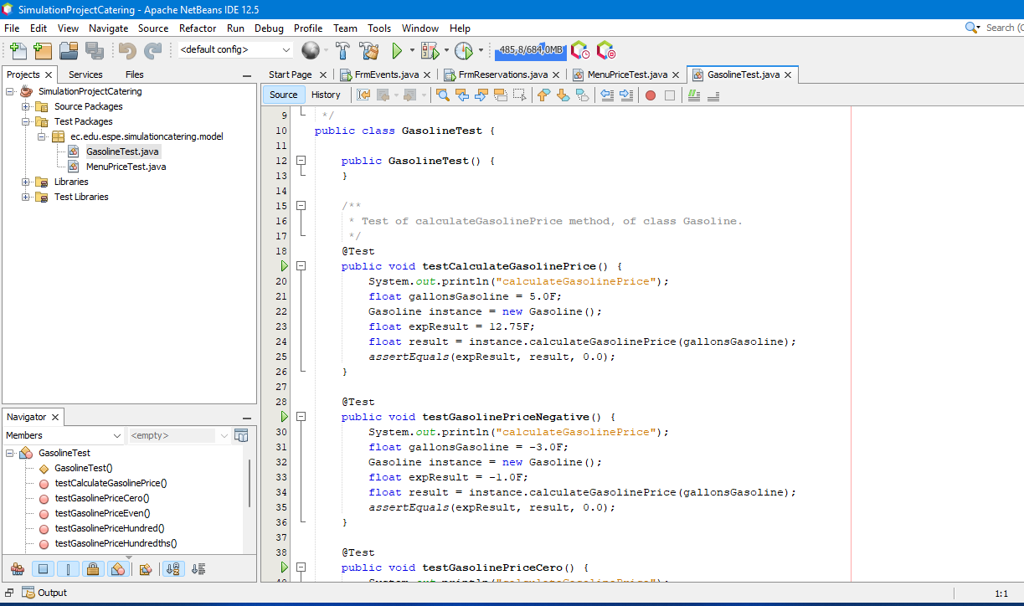

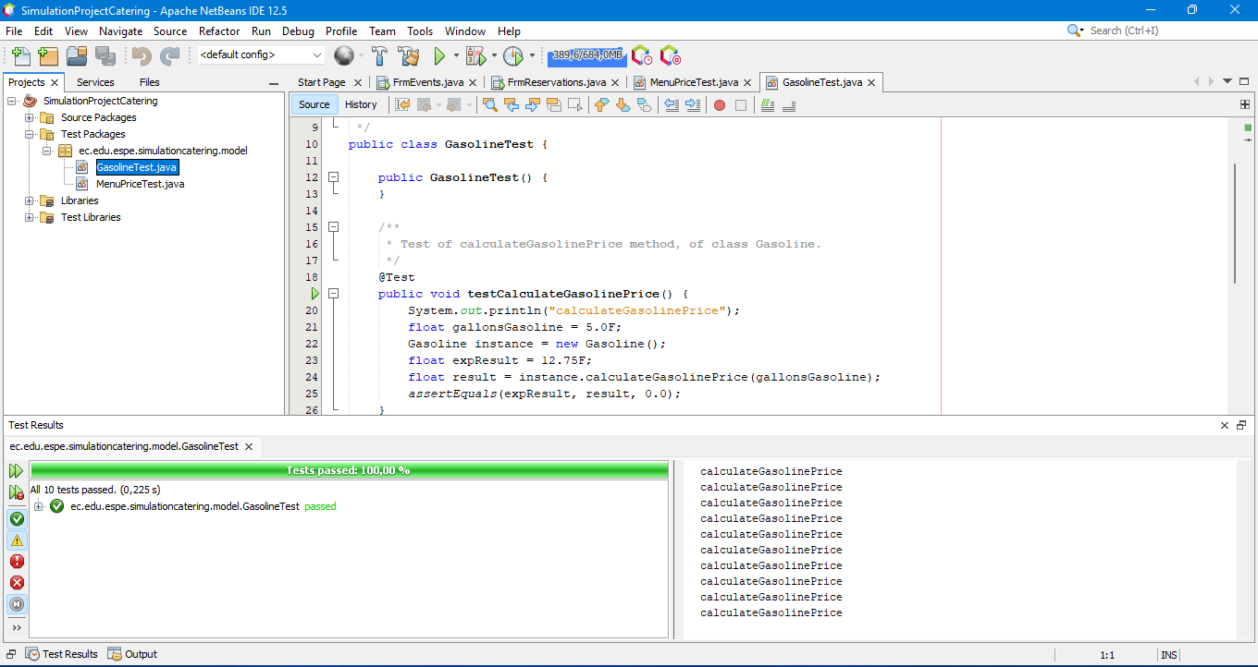

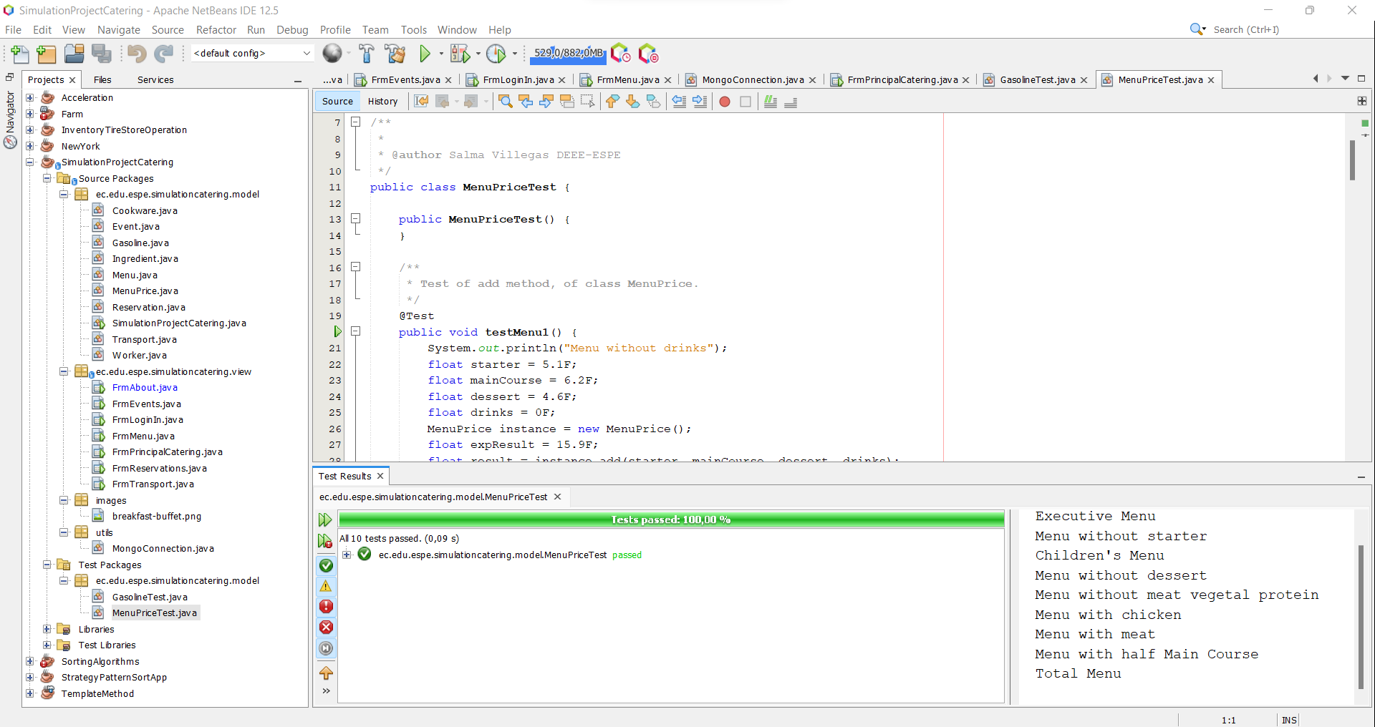

**GUI fields validation**

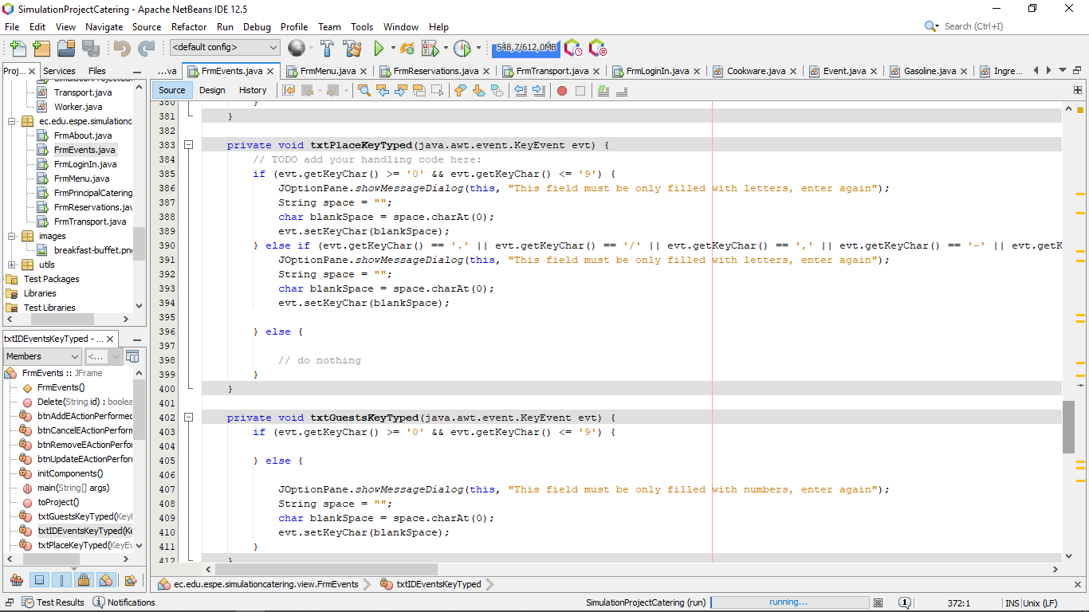

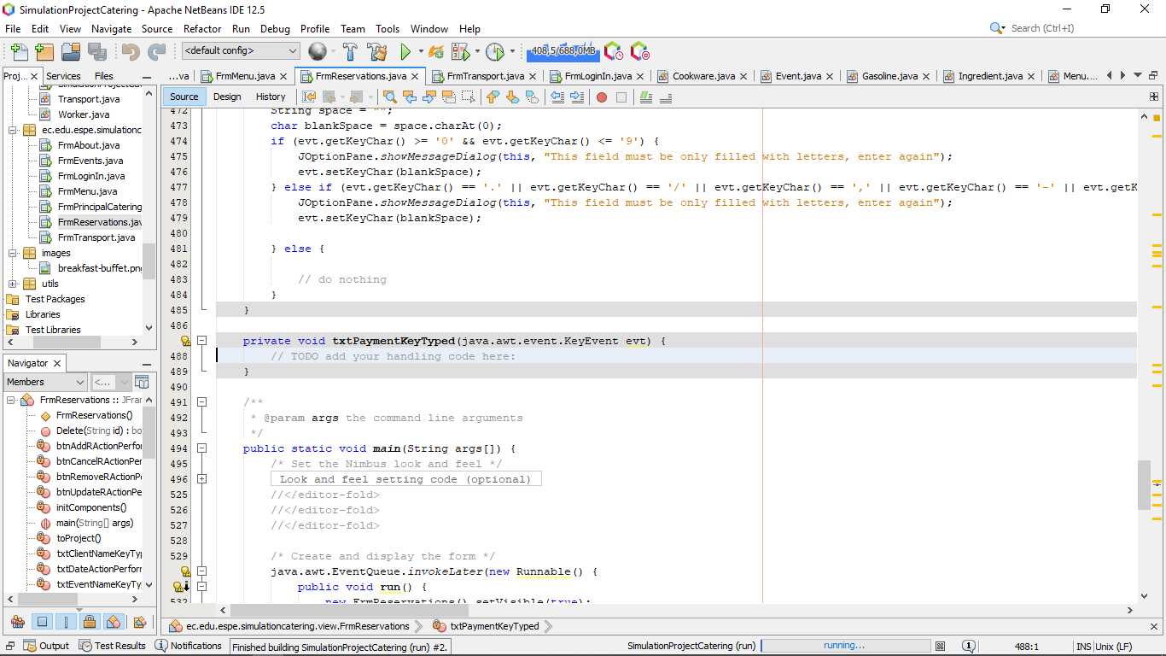

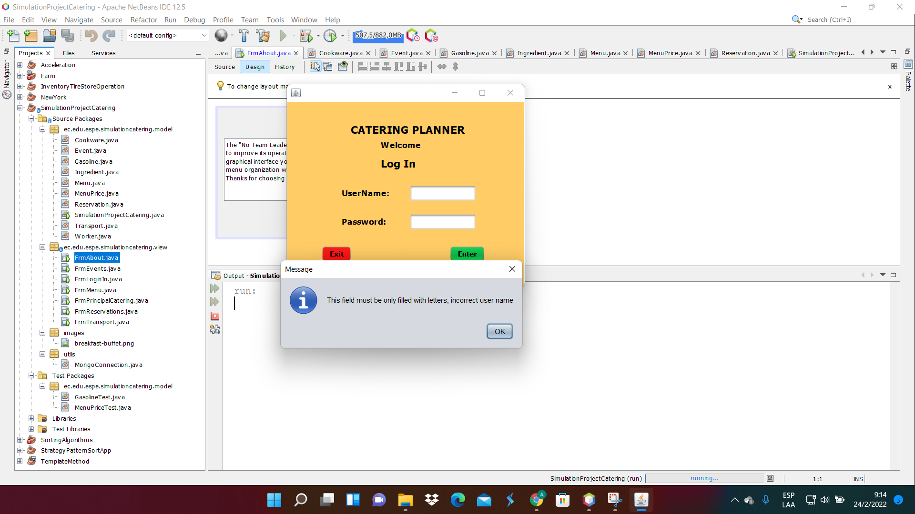

there is not validation in payment

**Functionality**

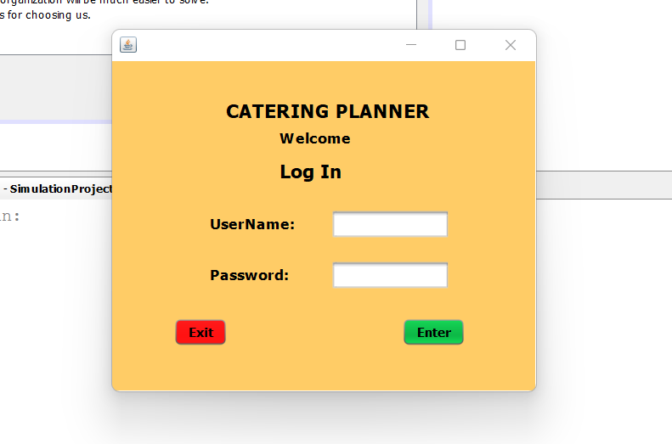

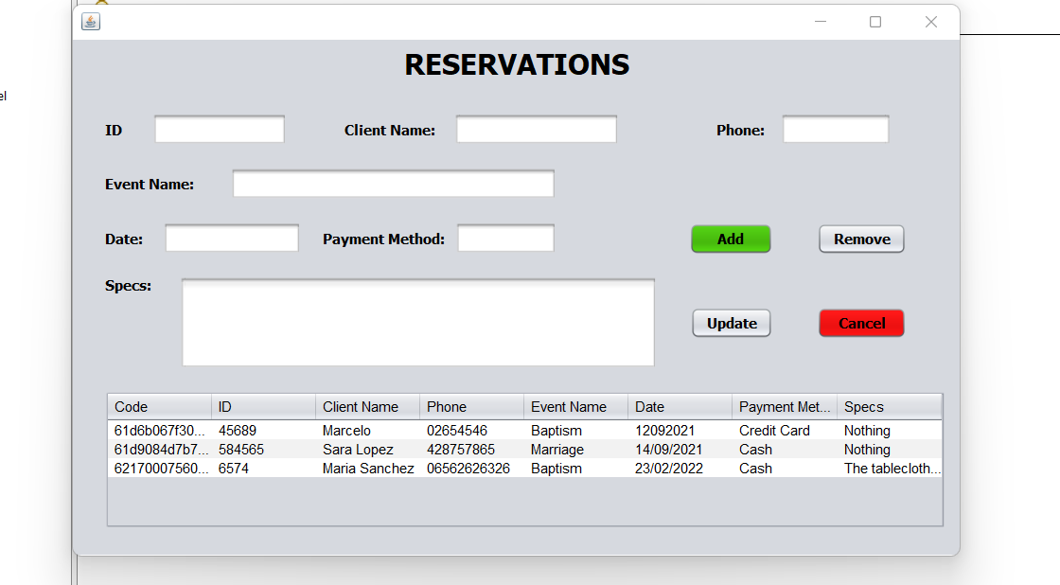

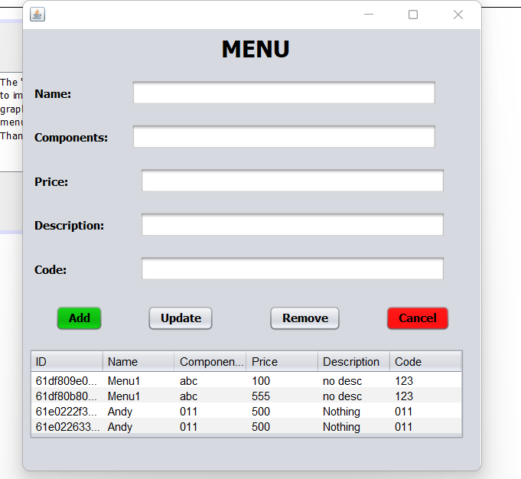

**MongoDB**

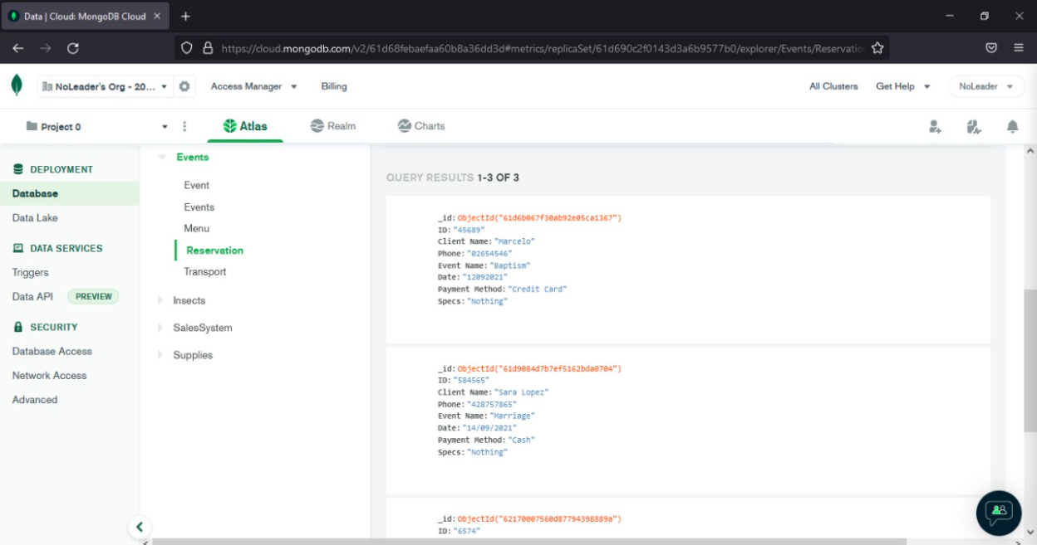

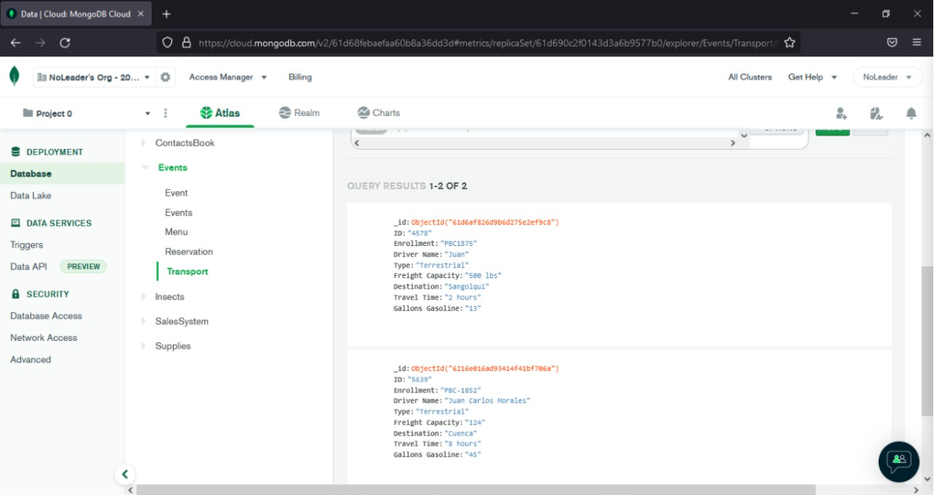

**GUI navigability Group 9¿**

**Execution Video Program Group 9**

[**https://drive.google.com/file/d/1XXOTqJqxpuwCNNH2JG3EELbIizxaufY_/view?usp=sharing**](https://drive.google.com/file/d/1XXOTqJqxpuwCNNH2JG3EELbIizxaufY_/view?usp=sharing)